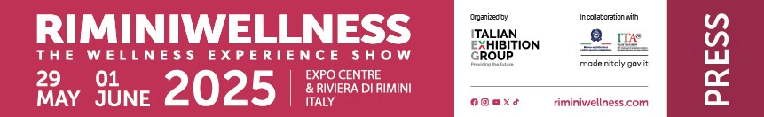

press release
(English translation)

RIMINIWELLNESS 2025: WELLNESS COMES THROUGH HEALTHY EATING
NEW ENTRIES IN THE FOODWELL AREA

- From May 29 to June 1 at IEG’s Rimini Expo Center, the return of historical partners and new brands for an edition of RiminiWellness under the banner of protein innovation
- From pasta to enriched drinks, food brands will be telling their stories through immersive experiences at the 19th edition of Italian Exhibition Group’s international event
- Space also for functional food trends including showcooking, talks and experiential formats proposed by ambassadors and innovative companies

Rimini (Italy), 15 May 2025 – RiminiWellness, the Italian Exhibition Group event and a global manifesto of fit living, will be back at Rimini Expo Center and on the Riviera from May 29 to June 1 with a 19th edition that will focus on promoting healthy eating as a viaticum for full physical and mental wellness. The six official thematic areas will include the FoodWell Area, which, packed with new ideas in a full program of content, will also feature functional nutrition’s top brands. From protein foods to functional beverages, vegan offers and sports nutrition, a journey between taste and health for a public that is becoming increasingly aware of what they put on the table.

THE FOODWELL AREA'S BIG PROTEIN COMPANIES
The Amadori Group - The Italian Protein Company will be the event’s Food Partner for the third year running. An Italian agri-food industry leader, the group will confirm its commitment to RiminiWellness with a wide range of protein specialties and, for the occasion, will also present new research on sarcopenia, a condition that affects about 30% of the over-65s in Italy, to promote the diet and health combination. An absolute new entry at the show, Barilla will be a key player with the new Barilla Protein+ line, a high-protein pasta designed for those who practice physical activity and seek the right balance between taste and nutrition. In the Fiteducation® Golden Stage, Barilla will also be offering a copious program of classes between dance and functional and combat training with international experts. Danone HiPRO, also confirmed to attend, will welcome participants in an experiential area equipped with a fitness stage in collaboration with BuddyFit, an online workout platform: an opportunity for attendees to receive personalized workout and nutrition advice and discover the line's protein products. Lastly, FunnyVeg, a consulting agency specializing in the plant-based world, will be back in Rimini with a series of events that combine taste and innovation, such as a workshop on a new fermented pasta with a high fiber and protein content; a gourmet-veg challenge in collaboration with the Kioene brand; and the presentation of Gemme, legume gnocchetti designed for those who want to combine flavor, speed and wellness in the kitchen.

FUNCTIONAL WATERS, WELLNESS ALSO COMES THROUGH HYDRATION
Healthy eating cannot ignore an essential element for physical wellness: hydration. The fortified water trend continues to be of great interest and, for the first time, Levissima+ will be a Hydration Partner, confirming its mission to become a reference point in the wellness field. Given ample space, Levissima+ will have a booth specifically for personal regeneration, where, on Sunday June 1, athlete and influencer, Giulia Calcaterra, will be appearing as special guest. Moreover, in Hall A4, Levissima+ and Jill Cooper will be engaging the public in Super Jump sessions, yoga and functional workouts. At the event, the brand will be supporting its “Let’s Regenerate Together” project aimed at promoting a healthy and environmentally friendly lifestyle. Acqua Sant'Anna will be present with its Sant'Anna PRO line designed for training and sports, especially for those who want to work out every day and feel good, while Acqua Minerale San Benedetto, will participate with Aquaprotein, water with 15 grams of protein, plus zinc and magnesium; Aquavitamin, a line of vitamin drinks in mineral water with the presentation of the new citron flavor; Skincare, with collagen, zinc and hyaluronic acid for a new beauty ritual; and Energade Protein, a replenisher with mineral salts and protein source. Lauretana will once again be a technical sponsor of the Active area by supplying water to all the various stages and activities both inside the Expo Center and at the RiminiWellness OFF settings.

FUNCTIONAL FOOD AND ALTERNATIVE APPROACHES, THE FUTURE OF NUTRITION AT THE SHOW
The FoodWell Area will be further enriched with alternative and creative proposals such as Ketobar, Italy's first and only ketogenic eatery based in Rimini, conceived by former cyclist, Mirco Bastianelli, who will hold a talk entitled “The role of the low-carb diet in sport,” during which Dr. Lorenzo Vieri, a sports physician, will illustrate the positive effects of the ketogenic approach on athletic performance and muscle growth with witness accounts from soccer players Eleonora Goldoni and Asia Bragonzi. Activities will also include a keto showcooking by chef Tomas Marfella and silent mode training sessions led by coach Maximilian Arcidiaco. Lastly, Heinz will be back as the Dressing Partner with offers such as Mayo Veg and Ketchup Zero, together with well-known brands such as Fage, Yoga, Valsoia, Ventura, Bekind, Novi and Mielizia. The latter will present a meeting on Saturday on the benefits of honey in daily nutrition, sponsored by CONAPI, Europe’s largest beekeeper cooperative.

THE AMBASSADORS' STORY
Completing the overview of this area is the Mysurable project developed with Bologna University, which offers cloud-based technology solutions for monitoring functional aging. Furthermore, the nutrition theme will also be expressed through some of the most popular wellness faces, such as Laura Crugnola from the Cotto al Dente community, nutritionist, Hyrox athlete and the edition’s main ambassador, and the 2foodfitlovers, Raffaele Del Piano and Caterina Piccirilli, who will be returning with their successful brands Fitporn and Even Gelato, expressions of the new frontier of functional food.

ABOUT RIMINIWELLNESS 2025
Dates: 29 May – 1 June 2025; event: international trade show; organization: Italian Exhibition Group S.p.A.; frequency: annual; edition: 19th; entry: public and trade; info: www.riminiwellness.com

PRESS CONTACT ITALIAN EXHIBITION GROUP
head of corporate communication & media relation: Elisabetta Vitali
press office manager: Marco Forcellini, Pier Francesco Bellini | press office coordinator: Luca Paganin | international press office coordinator: Silvia Giorgi | press office specialist: Mirko Malgieri; Nicoletta Evangelisti | media@iegexpo.it

MEDIA AGENCY RIMINIWELLNESS
Naper Multimedia| Zoe Perna | T. +39 02 97699600 | zoe.perna@napermultimedia.it | staff@napermultimedia.it

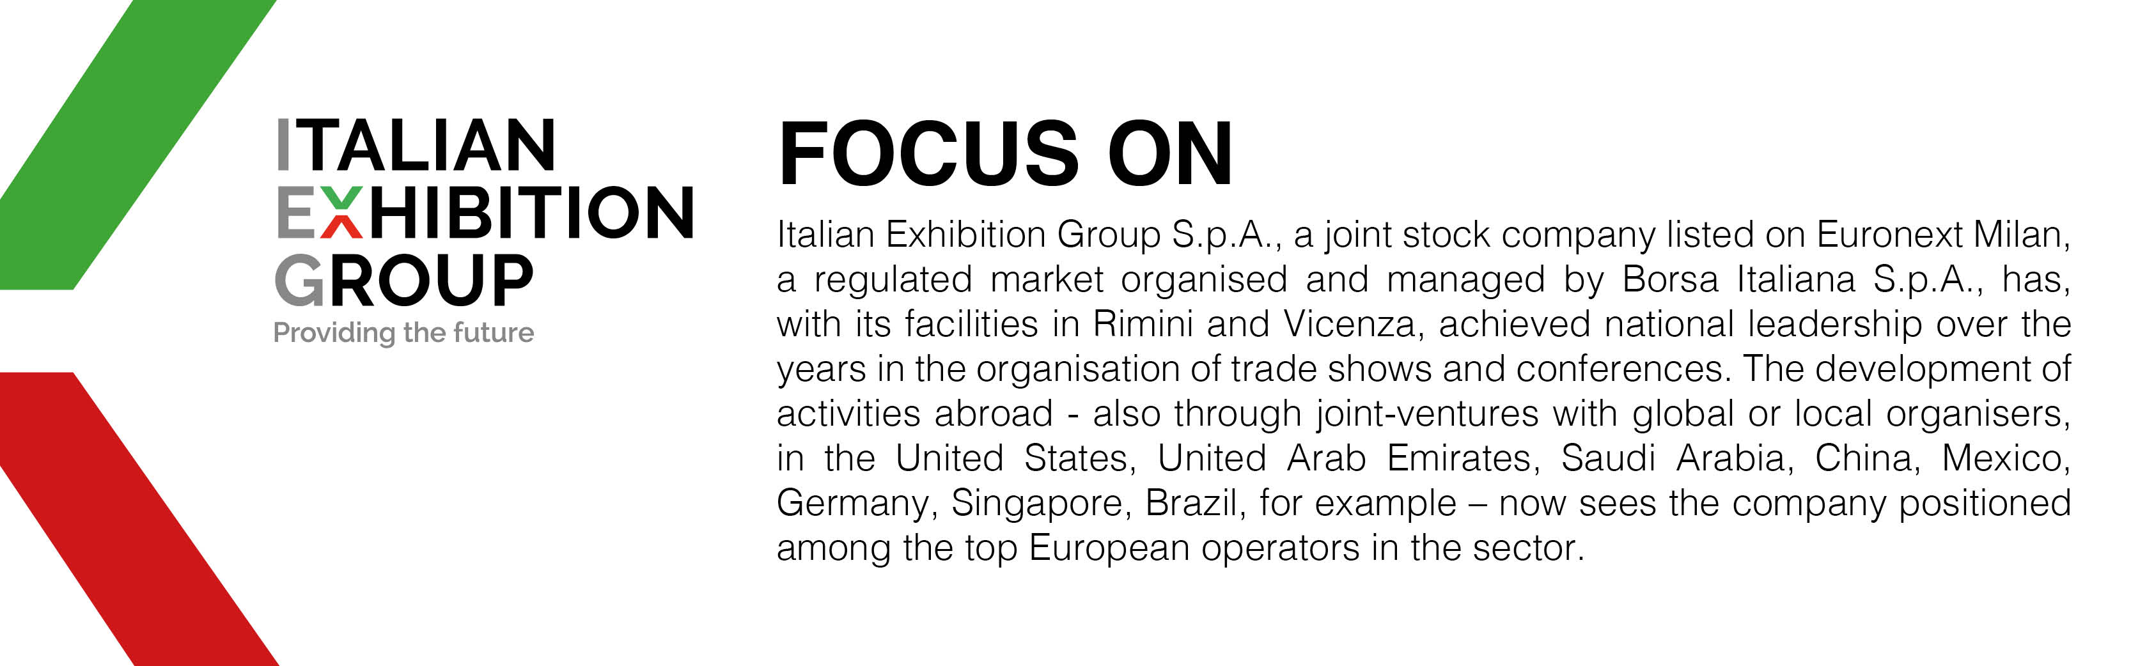

This press release contains forecast elements and estimates that reflect the management’s current opinions (“forward-looking statements”), particularly regarding future management performance, realization of investments, cash flow trends and the evolution of the financial structure. For their very nature, forward-looking statements have a component of risk and uncertainty, as they depend on the occurrence of future events. The effective results may differ (even significantly) from those announced, due to numerous factors, including, only by way of example: food service market and tourist flow trends in Italy, gold and jewellery market trends, green economy market trends; the evolution of raw material prices; general macroeconomic conditions; geopolitical factors and evolutions in the legislative framework. Moreover, the information contained in this release does not claim to be complete, and has not been verified by independent third parties. Forecasts, estimates and objectives contained herein are based on the information available to the Company as at the date of this release.

