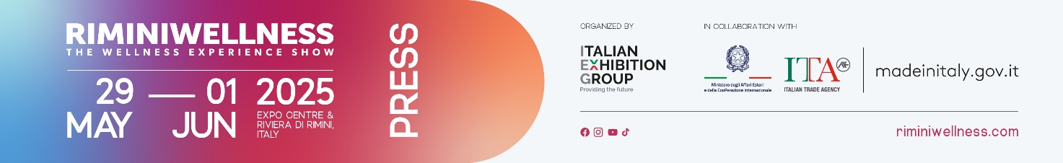

press release
(English translation)

RIMINIWELLNESS 2025: THE LATEST FITNESS TRENDS
FOR INTEGRATED WELLNESS

- Wood massages, facial reflexology, methods and equipment for postural coordination, and advanced indoor cycling are among the trends for physical balance.
- The international IEG event, running at Rimini Expo Centre and along the Riviera from May 29 to June 1, expands its offerings for holistic disciplines and high- and low-intensity practices.
- A comprehensive experience: over 2,000 hours of activities, six themed areas, and a vibrant community featuring ambassadors, talks, and training sessions.

Rimini (Italy), 26 May 2025 – RiminiWellness 2025 will be the international stage for trends in healthy living, expanding the range of innovative training disciplines. The event, curated by Italian Exhibition Group and scheduled at Rimini Expo Centre and along the Riviera in Italy, from May 29 to June 1, will feature six thematic areas, over 2,000 hours of training, 12 stages, and the presence of leading trainers and ambassadors in the industry. This unique experience will offer discovery and innovation in the most cutting-edge disciplines for physical balance.

INDOOR CYCLING IS CONSTANTLY EVOLVING
The American SoulCycle trend has exploded in recent years, but indoor cycling has always been a key feature at RiminiWellness. This year, it will continue to offer a highly motivational experience, set to the rhythm of music and light effects. The ICYFF® community will enliven the four-day event with Groupcycling® and Cyclex® sessions, focusing on endurance, muscle tone, and overall well-being. In the Les Mills brand experience area, visitors can explore the brand's iconic programs and the latest innovations, including LES MILLS SPRINT and LES MILLS RPM, featuring virtual loop workouts for fans of non-stop cycling.

COMBINED CARDIO IN ALL ITS FORMS
Combined cardio returns with Mobility, HIIT Training, and Functional sessions organised by MyPersonalTrainer and led by eight qualified educators, along with TAMBOO, a multisensory format that blends rhythm and spirituality through percussion. Strong Nation® will once again present CIRCL Mobility™, an innovative high-intensity and mobility workout set to music. Jill Cooper will return with her trainers and training sessions, including SuperJump, on the stage of Levissima +, the event's hydration partner. On the XXL stages of R3BEL Activewear and RiminiWellness, over 20 daily lessons will be held, featuring presenters like Anastasia Alexandridi, Guillermo Vega, and Ary Marques, three-time world aerobics champion. In addition, Rebel will present its new creative project, "PowerFlowers EcoVan," an artistic and sustainable experience designed for relaxation and meeting the presenters. For those who love slow yet intense rhythms, THEPOLE returns with its dedicated experience area for pole dancing and aerial disciplines. The FIF Village also debuts the You On Stage contest, with the grand finale on the opening day.

THE ENERGY OF WATER: TRAINING, RHYTHM, AND INNOVATION
The spotlight is on water with training methods that blend technique, rhythm, and wellness. FluidX Flow offers a unique exercise with the FX Cube, a water-filled, weight-adjustable tool that challenges the cardiovascular system and stabiliser muscles. AcquaFly offers a targeted workout to enhance balance, strength, and coordination. Zumba® will of course be present with its fun Aqua Zumba® sessions to burn calories, alongside traditional fitness programmes and Zumba Gold, designed for mature athletes with low-intensity yet functional movements.
EVOLUTIONARY WELLNESS: THE NEW FRONTIERS OF WELLNESS
RiminiWellness is expanding its holistic offerings, with a notable highlight being the evolution of the Pilates Reformer, the machine invented by Joseph Pilates. New models designed for even more precise training will be showcased at the show, thanks to the presence of top brands in the industry. Additionally, there will be an exclusive talk by FIF on the trend of the TechnoReformer, a format that combines Pilates-inspired exercises, pulsating electronic music, and immersive atmospheres. The Pilates Professionals Association in Italy (APPI) will offer a free programme of Matwork and equipment classes led by the directors of the leading Italian schools. They will also host talks on professional topics such as social security and opening studios. Meanwhile, Simona Oberhammer, a naturopath and creator of the Biotipi Oberhammer method, will explain how to train according to your biotype for lasting well-being in a dedicated session. Rotaction makes its debut - an innovative system designed to enhance body symmetry and harmony, integrated with the Loney Method, an evolutionary postural gymnastics approach. The programme will be complemented by daily talks titled "With Vaginaverso, women's well-being takes a voice," presented by Vaginaverso by Gyno-Canesten Inthima Cosmetic Lenitivo, the event's personal care partner. These talks, in collaboration with Sayonara Motta and doctors Monica Calcagni and Sabina Fasoli, will delve into the topics of intimate health and women's well-being with a scientific and inclusive approach.

FROM THE ROOTS OF EASTERN WISDOM TO CONSCIOUS MOVEMENT
The Oasis of Wellness will provide ample space for holistic practices and ancient rituals. Introducing Ubtàna, an Ayurvedic Rasayana Chikitsa treatment made from natural herbs and flours, renowned for its purifying and anti-aging properties. Diện Chẩn, a Vietnamese facial reflexology technique, is introduced to stimulate self-healing and energy balance. The presence of Maderocare™, a non-invasive massage using wooden instruments, has been confirmed. It is effective against cellulite, fluid retention, and muscle tension. The two Relax Zones will provide rejuvenating moments with a spacious area dedicated to massages. Great attention is also given to the 25th anniversary of BodyFly®, a holistic method created by Gennaro Setola, which combines movement, strength, and balance. This will be showcased on stage in collaboration with Sammontana for the launch of the new Amando ice cream. Finally, Yoga On Stage, presented by ReYoga, will offer open sessions to reconnect with your breath and body awareness.

THE EVENT’S AMBASSADORS: STORIES OF PASSION AND SUCCESS
This year, RiminiWellness will once again host the most beloved ambassadors of the fitness and wellness community, who will share the event through their social media channels and live moments. Among them are Giulia Martinelli and Vera Bettiol from the La Scimmia Yoga team, known for their dynamic Vinyasa style. Vida Macura Maglica, International Main Ambassador, will share tips on achieving your goals without restrictive diets through the Extreme Training® programme. Fitness will be represented by Cottoaldente, the Main Ambassador On Stage, who will gather his community for a group workout on Saturday. Nicolò Famiglietti and Daniel Enrico will also be present, offering workouts and Meet & Greets with their respective communities. Alice Basso, model and entrepreneur, will share her experience in the talk "Face Your Shades - Overcome Your Limits," discussing her journey to holistic wellness. Meanwhile, Martina Sergi will lead two sessions focused on improving hip and leg mobility and flexibility. Finally, Silvia Fascians will lead a workout to help you become more aware of your body.

ABOUT RIMINIWELLNESS 2025
Date: 29 May – 1 June 2025; event type: international expo; organiser: Italian Exhibition Group S.p.A.; recurrence: annual; edition: 19th; open to: general public and operators; info: www.riminiwellness.com

PRESS CONTACT ITALIAN EXHIBITION GROUP
head of corporate communication & media relation: Elisabetta Vitali
press office manager: Marco Forcellini, Pier Francesco Bellini | press office coordinator: Luca Paganin | international press office coordinator: Silvia Giorgi | press office specialist: Mirko Malgieri; Nicoletta Evangelisti | media@iegexpo.it

MEDIA AGENCY RIMINIWELLNE
Naper Multimedia| Zoe Perna | T. +39 02 97699600 | zoe.perna@napermultimedia.it | staff@napermultimedia.it

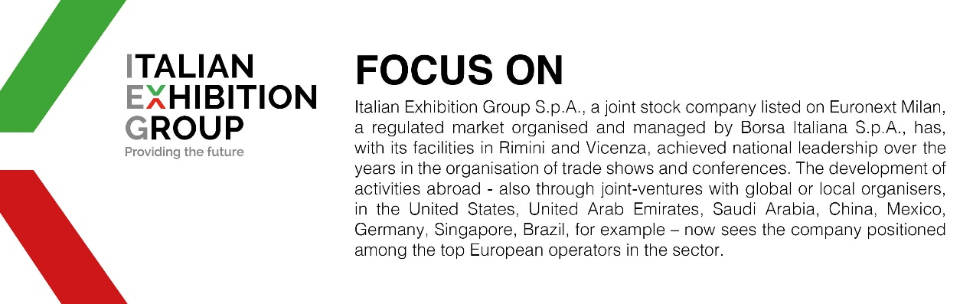

This press release contains forecast elements and estimates that reflect the management’s current opinions (“forward-looking statements”), particularly regarding future management performance, realization of investments, cash flow trends and the evolution of the financial structure. For their very nature, forward-looking statements have a component of risk and uncertainty, as they depend on the occurrence of future events. The effective results may differ (even significantly) from those announced, due to numerous factors, including, only by way of example: food service market and tourist flow trends in Italy, gold and jewellery market trends, green economy market trends; the evolution of raw material prices; general macroeconomic conditions; geopolitical factors and evolutions in the legislative framework. Moreover, the information contained in this release does not claim to be complete, and has not been verified by independent third parties. Forecasts, estimates and objectives contained herein are based on the information available to the Company as at the date of this release.

