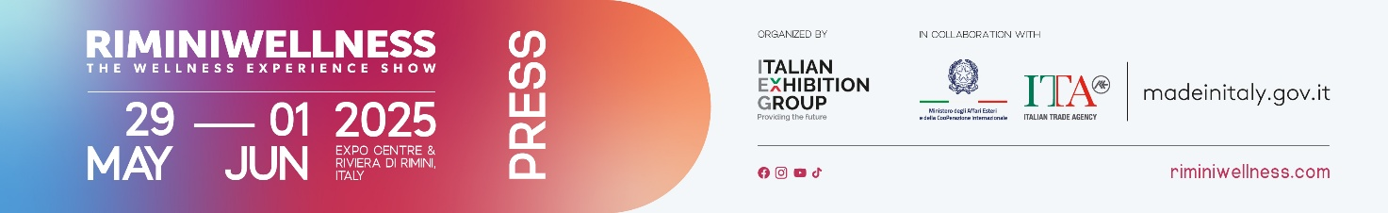

final press release
(English translation)

RIMINIWELLNESS 2025, + 30% INTERNATIONAL VISITORS, +32% OVERALL ATTENDANCE: A GIANT LEAP TOWARDS THE FUTURE OF WELLNESS

- 30 halls, 350 brands, 2,000 hours of activities, and 80 events: an authentic comprehensive format
- Focus on innovation, education, and sustainability
- Save the date for 2026: May 28-31

Rimini (Italy), 1° June 2025 – RiminiWellness is the strongest driver towards global wellness: this year marked a 30% increase on 2024 in terms of international visitors, primarily professionals. IEG's internationalisation strategy for its flagship products enables RiminiWellness to connect the industry with strategic markets worldwide, creating a virtuous cycle that ultimately benefits Rimini.
There was also extraordinary growth in overall attendance (Italy + abroad): +32% compared to the previous edition. These numbers highlight the great success of Italian Exhibition Group's (IEG) international event dedicated to fitness, sports, wellness, and healthy eating, which is currently drawing to a close at Rimini Expo Centre.

EXTRAORDINARY MEDIA VISIBILITY AND HIGH SOCIAL MEDIA ENGAGEMENT
552 accredited journalists, hundreds of TV and radio reports and live broadcasts, trade press articles, online and offline services and interviews, prestigious media partnerships with some of Italy's largest publishers, and explosive social media numbers have made RiminiWellness 2025 the symbol of the start of a very promising summer season, thanks in part to the many events scheduled throughout the local area.

BUSINESS, ENTERTAINMENT, AND NETWORKING AT THE HEART OF THE EVENT
Divided into six thematic areas and spread across 30 halls and 190,000m² of indoor and outdoor space at Rimini Expo Centre, RiminiWellness hosted over 350 exhibiting brands, 2,000 hours of training sessions for a wide audience of enthusiasts and athletes featuring the most innovative fitness disciplines, 80 conferences and events, and the involvement of more than 30 international associations. Showcasing at the event, international brands and the best of Made in Italy in sports equipment for training, healthy eating, nutrition, clothing, and services.

FOCUS ON MARKET AND INNOVATION
Business and innovation took centre stage at the debut of Fitness Franchising Day, in collaboration with Affilya and the General States of Fitness and Wellness. Key topics included corporate wellbeing, sector investments, and digital transformation. The Innovation Area, featuring 20 startups, fostered dialogue between research and industry, promoting new integrated solutions combining sports, health, and technology.

TRAINING, MADE IN ITALY, AND SHARED ENERGY
RiminiWellness 2025 by now has a reputation as being a major educational platform, accessible to healthcare professionals, trainers, students, and industry operators through workshops, talks, and sharing sessions. Among the highlights, the Forum on Sport and Sustainability, featuring contributions from partners including the Ministry of the Environment, the United Nations, CONI, and UEFA, offering a strategic look on the evolution of sport from 2030 to 2040. The event also hosted be the presentation of new studies, including "Wellness, the ranking of Italian provinces" in collaboration with Il Sole 24 Ore; "Fitness consumer market research in Italy," conducted by Les Mills with the contribution of IFO; and "Ageing processes and physical exercise," curated by the Italian Fitness Federation and the San Raffaele University of Rome.

AN ALL-ROUND EXPERIENCE FROM THE EXPO CENTRE ALONG THE RIVIERA WITH RIMINIWELLNESS OFF
RiminiWellness extended its energy beyond the walls of the expo centre, providing a collective experience of energy, inclusion, and well-being, at the third edition of RiminiWellness OFF. The "off-site" programme, organised in collaboration between IEG and the Municipality of Rimini, engaged the global community of enthusiasts and athletes with 200 events across the seafront, beach, city, and local areas.

IEG WELLNESS NETWORK
RiminiWellness is leading the global expansion of IEG Wellness Network, Italian Exhibition Group's pool of international industry events. Upcoming global events: • Dubai Active Show, Dubai Active Industry, Dubai Muscle Show | October 24-26, 2025, Dubai; • Riyadh Muscle | February 5-7, 2026, Riyadh, Saudi Arabia.

Save the date: RiminiWellness returns to Rimini in 2026, from Thursday, May 28 to Sunday, May 31: unstoppable energy!

ABOUT RIMINIWELLNESS 2025
Date: 29 May – 1 June 2025; event type: international expo; organiser: Italian Exhibition Group S.p.A.; recurrence: annual; edition: 19th; open to: general public and operators; info: www.riminiwellness.com

PRESS CONTACT ITALIAN EXHIBITION GROUP
head of corporate communication & media relation: Elisabetta Vitali
press office manager: Marco Forcellini, Pier Francesco Bellini | press office coordinator: Luca Paganin | international press office coordinator: Silvia Giorgi | press office specialist: Mirko Malgieri; Nicoletta Evangelisti | media@iegexpo.it

MEDIA AGENCY RIMINIWELLNESS
Naper Multimedia| Zoe Perna | T. +39 02 97699600 | zoe.perna@napermultimedia.it | staff@napermultimedia.it

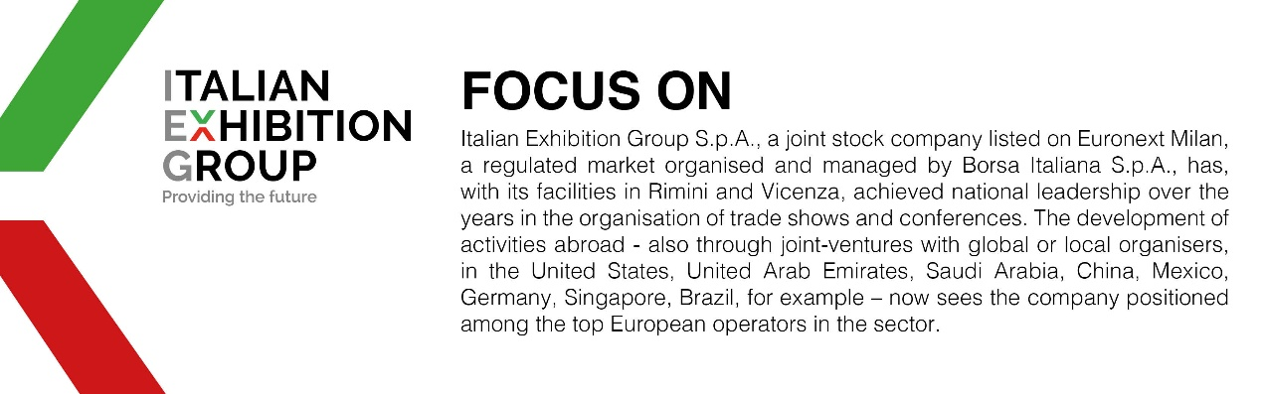

This press release contains forecast elements and estimates that reflect the management’s current opinions (“forward-looking statements”), particularly regarding future management performance, realization of investments, cash flow trends and the evolution of the financial structure. For their very nature, forward-looking statements have a component of risk and uncertainty, as they depend on the occurrence of future events. The effective results may differ (even significantly) from those announced, due to numerous factors, including, only by way of example: food service market and tourist flow trends in Italy, gold and jewellery market trends, green economy market trends; the evolution of raw material prices; general macroeconomic conditions; geopolitical factors and evolutions in the legislative framework. Moreover, the information contained in this release does not claim to be complete, and has not been verified by independent third parties. Forecasts, estimates and objectives contained herein are based on the information available to the Company as at the date of this release.

