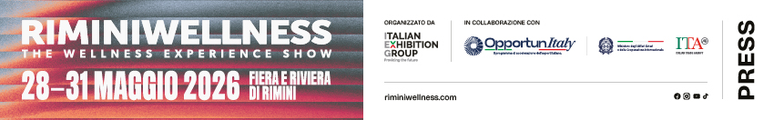

Press announcement

RIMINIWELLNESS 2026: THE 20-YEAR EDITION
WILL INAUGURATE A NEW AGE OF WELLNESS

- Italian Exhibition Group’s fitness, sport, wellness and healthy eating event will be back from 28th to 31st May with a global spirit
- An evolving ecosystem that integrates fitness, sport, sports medicine, nutraceuticals and cosmeceuticals, expanding the event's content and audience
- “Go Through”, an attitude that becomes a way of life, redefining the relationship between body and space
- RiminiWellness OFF will be back to connect the Show, the city and the entire Riviera in one single experience of movement and longevity

Rimini, 18th December 2025 – Body and dynamism, performance and innovation, movement and energy. This is the complete vision of wellness at RiminiWellness 2026, scheduled to take place at Rimini Expo Centre and on the Riviera from 28th to 31st May, to celebrate 20 years of the Italian Exhibition Group event. A milestone that opens a new chapter in the global promotion of healthy lifestyles with “Go Through”, the edition’s claim that sums up an immersive and dynamic event that will cross mind, body, spirit and environment.

2026 EDITION PREVIEWS
After the success of the 2025 edition, which confirmed RiminiWellness as a global platform for business, networking and on-the-move wellness culture with a 32% increase in the attendance of enthusiasts, athletes and professionals from all over the world, RiminiWellness 2026 will further strengthen the Health macro-theme, the common thread that links every area of the event.
Rimini Expo Centre’s 30 halls will host equipment, services and solutions to illustrate the sector’s evolution and confirm the growth of leading national and international brands. Fitness, sports medicine and physiotherapy contents will be central with movement increasingly understood as a tool for prevention, wellness, and quality of life, also in terms of longevity.
RiminiWellness will broaden the target audience by involving sports doctors, physiotherapists, nutritionists and qualified operators, boosting the contents to respond to a more complete and aware demand for wellness. Nutraceuticals and cosmeceuticals will also increase: the Active Beauty area, inaugurated in 2023, will combine aesthetics and physiological benefits through advanced formulations with a scientific, health-oriented approach.
Lastly, RiminiWellness 2026 will consolidate the experiential and supply chain trade show model with a “test and learn” logic by involving companies, professionals and end-users. To further strengthen international leadership, 2026 will inaugurate new networking projects, especially the two activities linked to Industry Leaders, with international speakers able to engage professionals and others on the topics of innovation in sport, business fitness, wellness trends, hospitality, travel destinations and sustainability, supported by Industry Experts, a team of sector experts that can make this content accessible to the entire community.

FROM ART TO WELLNESS
The new RiminiWellness 2026 campaign draws inspiration from the dynamic art of Boccioni and Balla. In the visual, training becomes pure energy, a flow that merges the athlete with the surrounding area. The protagonist of the campaign is an athlete with blurred contours, immersed in an out-of-focus space where, rather than the sporting gesture, it is the trace it leaves that counts, a rhythm that expands beyond physical, mental and geographical boundaries. A movement that becomes experience.

GO THROUGH: THE ART OF CROSSING MOVEMENT
“Go Through” it is not just a theme, but a way of life that the coming 2026 edition will propose. It is the physical crossing of the halls, the Expo Centre, the city and the Riviera, but also a mental, emotional and sensorial crossing. The experience becomes complete only by letting oneself be crossed by movement, and immersing oneself in its continuously transforming energy. The concept translates into a vibrant visual imagery, a powerful, contemporary language that speaks to a large, heterogeneous and constantly growing community.

RIMINIWELLNESS OFF: WELLNESS WITH NO BOUNDARIES
RiminiWellness it is not confined to the Expo Centre: in 2026, the event will once again extend across the entire city and the Riviera with activities, events and participatory moments that will involve residents, athletes, gyms and local companies. This is the spirit of RiminiWellness OFF, which, now at its fourth edition, will accompany the Show with widespread and complementary initiatives, creating a unique wellness experience across the entire urban fabric.

ABOUT RIMINIWELLNESS 2026
Dates: 28/31 May 2026; event: international trade show; organization: Italian Exhibition Group S.p.A.; frequency: annual; edition: 20th; entry: public and trade; info: www.riminiwellness.com

PRESS CONTACT ITALIAN EXHIBITION GROUP
head of corporate communication & media relation: Elisabetta Vitali
press office manager: Marco Forcellini, Pier Francesco Bellini | press office coordinator: Luca Paganin | press office specialist: Mirko Malgieri; Nicoletta Evangelisti | press office assistant: Julia Andreatta media@iegexpo.it

MEDIA AGENCY RIMINIWELLNESS 2026
Naper Multimedia| Zoe Perna | T. +39 02 97699600 | zoe.perna@napermultimedia.it | staff@napermultimedia.it

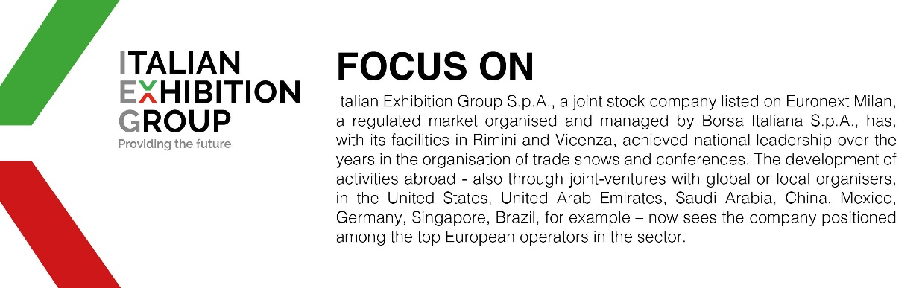

This press release contains forecast elements and estimates that reflect the management´s current opinions (´forward-looking statements´), particularly regarding future management performance, realization of investments, cash flow trends and the evolution of the financial structure. For their very nature, forward-looking statements have a component of risk and uncertainty, as they depend on the occurrence of future events. The effective results may differ (even significantly) from those announced, due to numerous factors, including, only by way of example: food service market and tourist flow trends in Italy, gold and jewellery market trends, green economy market trends; the evolution of raw material prices; general macroeconomic conditions; geopolitical factors and evolutions in the legislative framework. Moreover, the information contained in this release, does not claim to be complete, and has not been verified by independent third parties. Forecasts, estimates and objectives contained herein are based on the information available to the Company as at the date of this release.

