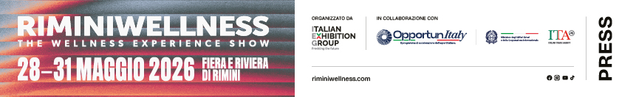

press release
RIMINIWELLNESS 2026 WILL BRING WORLD LEADERS AND EXPERTS TO ITALY TO GUIDE THE TRAJECTORIES OF WELL-BEING

- The World Active Summit has chosen Rimini for the first time in its history as the venue for its General Assembly and to elect its new world Board
- The Global Fitness Leaders Meeting will see delegates from over 20 countries gather to define the profession’s new international standards and promote trainer mobility
- The Industry Leaders & Experts programme ignites the debate on artificial intelligence, new revenue models, and the best sports medicine thanks to the partnership with Isokinetic

Rimini, 18th March 2026 – The decision-making epicentre of global wellbeing: this is the trajectory of the 20th edition of RiminiWellness, Italian Exhibition Group’s (IEG) fitness, wellness, sport and healthy eating event, which further strengthens its positioning as a strategic platform for international business. The event, scheduled to take place from 28th to 31st May at Rimini Expo Centre and on the Riviera, will transform the exhibition facility into an ecosystem where institutions, large club chains and technological innovators will define the industry’s global scenario, where the rules of tomorrow's market are written through direct debate between the world's top stakeholders.

THE SECTOR’S WORLD LEADERS IN RIMINI: WORLD ACTIVE AND GLOBAL LEADERS
World Active, the global platform that unites fitness, wellness and physical activity associations and professional registers, announces its Third World Active Summit, taking place on Friday, 29 May 2026, in partnership with RiminiWellness in Rimini, Italy. This year’s Summit will be of particular significance. In addition to strategic dialogue among international leaders, the event will host the World Active General Assembly and the election of a new Board of Directors, a decisive moment that will shape the next chapter of the organization and define its global leadership for the coming term as well as help position physical activity as a central pillar of public health, prevention and economic sustainability including cooperation with global institutions such as the World Health Organization.
The Global Fitness Leaders Meeting, a summit co-organized by REPs Polska and Poland Active, will take place concurrently on Saturday, May 30. Its purpose is to exchange knowledge and experience on fitness education systems, professional registration, and international standards, as well as to support trainer mobility and cooperation across borders. The meeting will feature leaders from over 20 countries and their representatives, including Amy Boone Thompson and Graham Melstrand (USA), Richard Beddie (New Zealand), Monica Marques (Brazil), Samir Kapoor (India), Catherine Hanson (UAE), Spencer Moore (UK), and Mohamed Mahmoud (Egypt). The network will also be represented by delegates from Oman (Fatemah Raeisi, Julie Willetts), the Czech Republic (Jana Havrdová, Klára Benešová), Poland (Edyta Bartejczuk-Wolak), Italy (Luca Dutto), Ukraine (Marina Toropova, Vadim Gumenuk), Malta (Mahdi Jafargholizadeh), and the Netherlands (Emiel Van Triest). Participants will take part in person, via Zoom, or through national presentations to foster open dialogue aimed at building an ethical and globally connected fitness industry.

SCIENCE AND PERFORMANCE: ISOKINETIC SPORTS MEDICINE PARTNER
The Health sector of RiminiWellness 2026 is further strengthened through a partnership with Isokinetic, an international medical group and FIFA Medical Centre of Excellence and Sports Medicine Partner. Specialising in the prevention, treatment and rehabilitation of orthopaedic and sports injuries, Isokinetic stands out for a specific clinical approach that adheres to rigorous biological and biomechanical criteria in its daily pursuit of excellence for the patient. At RiminiWellness an elite multidisciplinary team including sports doctors, physiatrists, physiotherapists, chiropractors and nutritionists will be on hand to share specialised clinical activities and personalised approaches that integrate FIFA sports medicine at the heart of the wellness industry. The group will participate with technical and scientific content and brand vision led by scientific director Francesco della Villa: “The Isokinetic Medical Group is delighted to be the Sports Medicine partner for the upcoming edition of RiminiWellness,” he stated, emphasising how the two organisations share the same strategic objective: to improve quality of life through exercise and the promotion of an active lifestyle.

INNOVATION AND BUSINESS: INDUSTRY LEADERS IN ARENA
Business contents at RiminiWellness will be enhanced by new speakers: Industry Leaders—international professionals recognized globally for their vision of how to develop fitness from a corporate perspective—and Industry Experts: industry experts and professionals who will focus on topics like health, wellness travel, nutrition, and physiotherapy, with a particular emphasis on the Italian market.
The debate on the future of fitness, wellness, and physical activity clubs will take place in the Fitness Innovation Arena located in Hall B3 and will start with the workshop "How gyms can unlock new revenue streams by understanding real user needs", From Memberships to Meaning, an interactive workshop led by Natalia Karbasova (Founder, FitTech Club), one of Europe's leading voices on fitness business transformation. The session will address a critical challenge facing the industry: as member expectations evolve beyond physical fitness toward longevity, community, and personal meaning, most operators still compete on price and equipment alone. Through moderated panels and structured expert networking, Karbasova and six international industry leaders will map concrete revenue opportunities across three shifts reshaping the market: premium brand positioning, the rapidly growing 45+ longevity economy, and AI-driven personalization. Contributing to the session will be Jörg Fockenberg (RSG Group), Emma Barry (Trouble Global), Naomie Martín (Mio Clubs), Jürgen Mehrtens (YEARS), Jörn Watzke (Garmin Health), and Anton Marchanka (Zing Coach). The workshop will close with themed expert tables, giving operators direct access to speakers for guidance on their own business models — a format designed to turn strategic insight into actionable next steps. This will be followed by a workshop with a focus on "Human First, Tech Forward: AI’s Role in the Future of Fitness & Health Coaching", with Kathleen Ferguson and Igor Castiglia. The event will explore the role of artificial intelligence in coaching, balancing technological value with the central importance of human connection. Castiglia, an industry expert with extensive experience in the fitness sector, will also lead the talk “From Fitness to Stress Management: how clubs can truly influence people’s wellbeing”: tools, skills and technologies that enable clubs to provide spaces capable of enhancing both athletic performance and an individual’s physiological balance.
The day’s programme will be rounded off by the REX Roundtables, moderated by Fausto Di Giulio. The REX World Fitness Panel will bring to Rimini the international visions of Aleksander Wilewski (Poland), Fahad Alhagbani (Armah Sports Company, Saudi Arabia), and Barry Walsh (Iconic Health Clubs, Ireland). At the same time, a specific focus will be placed on developing the domestic market through the contributions of Matteo Morandini (Passion Fitness Roma), Andrea Bacci (Golden Sporting Calenzano), Massimo Iermani and Pasquale Balbi (Catena Pump), who will share three different business models for addressing the challenges of the Italian fitness industry. Palestre di Successo’s training program and Alessandro Madonia’s strategic business consulting will be back, featuring five sessions designed for gym owners and trainers to help them expand their businesses with tailored-made solutions.
Numerous topics will be addressed over the four days of the event in the various arenas at RiminiWellness: inclusion, physiotherapy, holistic wellbeing, wellness travel, nutrition and health, with Industry Experts Andrea De Beni, who will be presenting the Adaptive Workout, a free body, clear mind and open heart workout designed to stimulate growth and overcome physical and other limits with creativity; Simona Oberhammer, Mondadori bestselling author, who will be presenting the book “The Gymintima Method - Intimate gymnastics for women, men and athletes” on the importance of the pelvic muscles for sports performance; Paola Rizzitelli will be heading a panel on wellness tourism with the participation of Simona Tedeschi, director of DOVE, Vincenzo Primitivo, spa doctor, Raffaella DiSipio, director of ItalCares, Annalisa Giannini from IEG’s congress division, and Elena Andreoli from Terme di Comano.
Lastly, through its Culinary Wellness Solutions, the ALMA – The International School of Italian Cuisine has chosen Rimini to launch its new Master in Health and Performance Chef, transforming food into a strategic asset for longevity clinics, sports companies and B2B hospitality.

ABOUT RIMINIWELLNESS 2026
Dates: 28/31 May 2026; event: international trade show; organisation: Italian Exhibition Group S.p.A.; frequency: annual; edition: 20th; entry: public and trade; info: www.riminiwellness.com

PRESS CONTACT ITALIAN EXHIBITION GROUP
head of corporate communication & media relation: Elisabetta Vitali
press office manager: Marco Forcellini, Pier Francesco Bellini | press office coordinator: Luca Paganin | press office specialist: Mirko Malgieri; Nicoletta Evangelisti | press office assistant: Julia Andreatta media@iegexpo.it

MEDIA AGENCY RIMINIWELLNESS 2026
Naper Multimedia| Zoe Perna | T. +39 02 97699600 | zoe.perna@napermultimedia.it | staff@napermultimedia.it

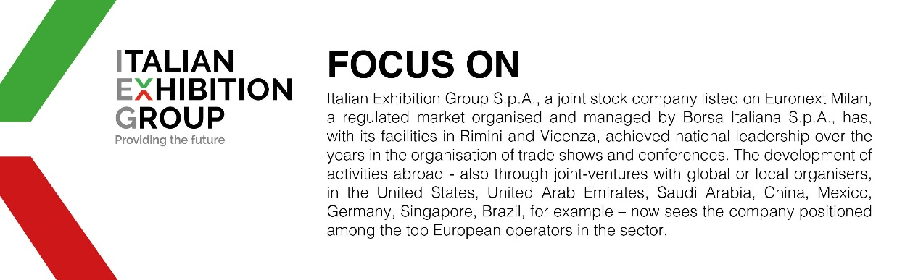

This press release contains forecast elements and estimates that reflect the management´s current opinions (´forward-looking statements´), particularly regarding future management performance, realization of investments, cash flow trends and the evolution of the financial structure. For their very nature, forward-looking statements have a component of risk and uncertainty, as they depend on the occurrence of future events. The effective results may differ (even significantly) from those announced, due to numerous factors, including, only by way of example: food service market and tourist flow trends in Italy, gold and jewellery market trends, green economy market trends; the evolution of raw material prices; general macroeconomic conditions; geopolitical factors and evolutions in the legislative framework. Moreover, the information contained in this release, does not claim to be complete, and has not been verified by independent third parties. Forecasts, estimates and objectives contained herein are based on the information available to the Company as at the date of this release.

