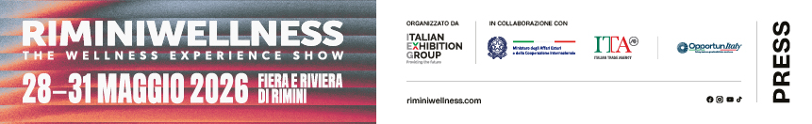

press release

RIMINIWELLNESS 2026, THE TWENTIETH EDITION OPENED TODAY

- The Italian Exhibition Group event has started welcoming a large international public to Rimini Expo Centre and on the Riviera for four days under the wellness banner
- The core of the opening ceremony: models linked to sustainability and the value of sport for the community
- The energy of international competitions kicks off while the Innovation Area spotlights the technological and strategic development of the entire sector

Rimini, 28th May 2026 – The wait is over: the twentieth edition of RiminiWellness, the Italian Exhibition Group (IEG) international event, kicked off today. Ongoing until Sunday 31st, Rimini Expo Centre and the Riviera will become the heart of sport, innovation and wellness. An opening in the name of energy, with 30 halls and over 190,000 m² of internal and external areas setting the stage for competitions, demonstrations and sporting activities, while the Rivera is now alive with the activities of RiminiWellnessOFF, the fourth edition of the off-show event, organised in collaboration with the Municipality of Rimini.

THE RIBBON-CUTTING CEREMONY: THE INSTITUTIONS GET THE TWENTIETH EDITION UNDERWAY
The main topic of the event’s opening ceremony was sport and wellness as a lever for business and territorial innovation and development. Speeches were given by IEG president Maurizio Ermeti; the mayor of Rimini, Jamil Sadegholvaad; the president of the Autonomous Region of Friuli-Venezia Giulia, Massimiliano Fedriga; the Italian Trade Agency’s central director for export sectors, Maurizio Forte; the Undersecretary of State for the Environment and Energy Security, Claudio Barbaro; and Emilia-Romagna’s regional councillor for tourism, commerce and sport, Roberta Frisoni.

INTERNATIONAL CHALLENGES AND HIGHER EDUCATION: THE STORY ON DAY 1
Sports training and competitions merge with the excellence of professional development at the Show. Setting the pace immediately after the opening was Hyrox, a key feature with four days of competitions ready to test the resistance of thousands of athletes. Panatta is offering two excellent events: the Panatta Rimini Contest and the Diamond Cup Rimini. Challenges will intensify further with Italian Showdown 2026, the Italian CrossFit® community’s big celebration, which will start tomorrow. Sporting performances will be accompanied by updating for sector operators. RiminiWellness, in fact, is staging a European preview presentation of the new Water Cross discipline, a protagonist on the Acquapower Stage, while Matrix Fitness has inaugurated its Educational Lounge, a program of seminars on crucial topics such as business management, AI, longevity and performance.

INNOVATION AREA: START-UPS, TOURISM AND NEW CONNECTIONS FOR THE FUTURE OF WELLNESS
In the Innovation Area at ​​RiminiWellness, start-ups, scale-ups and research teams will be presenting innovative solutions for the world of wellness. Created with Tecnopolo di Rimini, Clust-ER Health, Clust-ER Turismo Emilia-Romagna and ANGI, the area aims to foster business, new mentorship opportunities and the encounter between innovative projects, incubators and accelerators. The Pitch Competition is scheduled for Saturday 30th May with 30 startups and innovative SMEs on health, AI, nutrition, wellness tourism, longevity and sport economy.

THE FUTURE OF SPORT EMBRACES ENVIRONMENT, INCLUSION AND SOCIAL IMPACT
This afternoon will see the forum entitled “Sport that generates value for the environment and community", sponsored by the Minister for Disabilities and the Ministry of the Environment. Undersecretary of State Claudio Barbaro will be in attendance with speeches by Fabio Salerno and Niclas Svenningsen (UNFCCC). Andrea Capobianco, the women's national basketball team coach, will be the last to speak. The forum will continue tomorrow with the training course “Sustainability as a business lever”,on good practices for sports management. It will open with greetings from the Minister for Disabilities Alessandra Locatelli. Featuring clubs, companies and organisations, such as Juventus FC, NATIVA, GOfit, SCARPA and EPSI, it will offer a chance to learn about low-impact event organisation, the circular economy and European funding.

EVENTS ON DAY 2: BETWEEN WELLNESS TOURISM AND CUISINE
The international prestige of RiminiWellness is confirmed by the first Italian edition of the World Active Summit, scheduled to take place in Sala Diotallevi 2. For its third General Assembly and the election of its new Board of Directors, World Active has chosen Rimini as the venue for defining the federation's leadership and strategies for the coming years, strengthening the role of physical activity as a cornerstone of public health in collaboration with the World Health Organization (WHO).
The data and analyses that will be presented in the Body&Mind Arena by CNA Emilia-Romagna will highlight how Slow Tourism, cycle tourism and territorial experiences are helping to generate new local economic models. Speakers will include Roberta Frisoni, regional councillor for Tourism, Laura Sillato, president of CNA Tourism and Trade Emilia-Romagna, Nicola Cesari, mayor of Sorbolo Mezzani, Susanna Maggioni, vice president of FIAB Italia, and Christian Bertoni, vice president of APS Senio e Gesso. Meetings will continue in the afternoon with the future scenarios of Wellness Tourism, conducted by Paola Rizzitelli.
The debate on the future of fitness and wellness clubs between sector trends, communities and strategies will continue in the Fitness Innovation Arena (B3) with a workshop led by Industry Leader Natalia Karbasova, founder of FitTech Club, one of Europe’s most authoritative voices on fitness business.
Also scheduled is “Human First, Tech Forward: AI's Role in the Future of Fitness & Health Coaching”, a technological focus with Kathleen Ferguson and Igor Castiglia, who will delve into the role of artificial intelligence in coaching between technological value and the centrality of the human relationship.
Lastly, through its Culinary Wellness Solutions division, the ALMA - The International School of Italian Cuisine will be previewing in Rimini the new Master in Health and Performance Chef, transforming food into a strategic asset for longevity clinics, sports companies and B2B hospitality.

ABOUT RIMINIWELLNESS 2026
Dates: 28/31 May 2026; event: international trade show; organisation: Italian Exhibition Group S.p.A.; frequency: annual; edition: 20th; entry: public and trade; info: www.riminiwellness.com

PRESS CONTACT ITALIAN EXHIBITION GROUP
head of corporate communication & media relation: Elisabetta Vitali
press office manager: Marco Forcellini, Pier Francesco Bellini | press office coordinator: Luca Paganin | press office specialist: Mirko Malgieri; Nicoletta Evangelisti | press office assistant: Julia Andreatta media@iegexpo.it

MEDIA AGENCY RIMINIWELLNESS 2026
Naper Multimedia| Zoe Perna | T. +39 02 97699600 | zoe.perna@napermultimedia.it | staff@napermultimedia.it

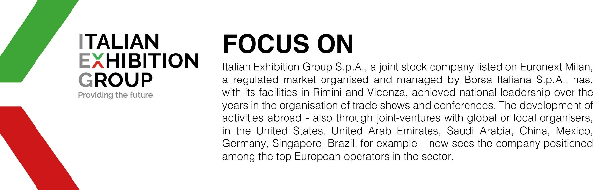

This press release contains forecast elements and estimates that reflect the management´s current opinions (´forward-looking statements´), particularly regarding future management performance, realization of investments, cash flow trends and the evolution of the financial structure. For their very nature, forward-looking statements have a component of risk and uncertainty, as they depend on the occurrence of future events. The effective results may differ (even significantly) from those announced, due to numerous factors, including, only by way of example: food service market and tourist flow trends in Italy, gold and jewellery market trends, green economy market trends; the evolution of raw material prices; general macroeconomic conditions; geopolitical factors and evolutions in the legislative framework. Moreover, the information contained in this release, does not claim to be complete, and has not been verified by independent third parties. Forecasts, estimates and objectives contained herein are based on the information available to the Company as at the date of this release.

