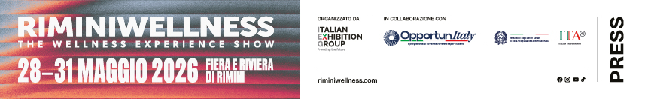

press release 2

RIMINIWELLNESS STRENGTHENS ITS LEADERSHIP
BETWEEN SPORT, SCIENCE AND HIGHER EDUCATION

- IEG’s international event, scheduled for 28-31 May at Rimini Expo Centre and the Riviera, extends its offer of scientific content for health and sports professionals
- The Health area will be bigger with a calendar of events that will include sports medicine, rehabilitation, training and nutrition
- The Beauty Area will be making its debut with events, experiences and in-depth discussions on cosmeceuticals, active skincare and sport

Rimini, 28-31 May 2026 – Sports medicine, advanced rehabilitation and nutraceuticals will be the focus of RiminiWellness 2026, the international fitness, sport, wellness and healthy eating event, organised by Italian Exhibition Group (IEG). Scheduled to take place from 28th to 31st May at Rimini Expo Centre and on the Riviera, the 20th edition will combine high-profile training, scientific innovation, and discussion between professionals, companies and communities, strengthening the event's international flair and its ability to anticipate developments in the sector.

SPORTS MEDICINE between TRAINING AND INNOVATION
The Health area will be a meeting point of excellence between sport and science. A unique opportunity to improve skills, discover the sector’s latest developments and meet a qualified audience of professionals through advanced training sessions and workshops aimed at physiotherapists, osteopaths and sports doctors. These will include the Project Invictus area and content from FisioScience, one of the most authoritative communities in physiotherapy and rehabilitation, which will feature Valerio Barbari in sessions offering specialist speeches and talks on the most relevant topics in modern rehabilitation. Sunday 31st May will see a conference on “Sport-Omics and Epigenetics in Performance: Training, Resilience, Recovery and Endurance” with Giorgio Terziani, visiting professor in wellness disciplines at the Saint George training school. In addition, thanks to Objective Performance, the Velocity Based Training Summit will be held on the same day. With Antonio Squillante in attendance, the training event will focus on the theoretical and practical exploration of one of the most advanced methods for monitoring and self-regulating training through execution speed analysis.

THE MOVEMENT & THERAPY SUMMIT WILL BE BACK
The new frontiers of rehabilitation and sports performance will be spotlighted with the Movement & Therapy Summit on Friday 29th May, an area for interdisciplinary dialogue between science and practical application, created with the aim of overcoming the fragmentation between the clinical and training fields. Conceived by Marco Rovatti, doctor of physiotherapy and qualified osteopath, registered with the ROI – Italian Osteopath Register, (FT, DO, SM, MSc), the summit will host Gray Cook for the first time in our country, founder of the FMS - Functional Movement Screen protocol and co-creator, together with Lee Burton, of the SFMA - Selective Functional Movement Assessment. The programme foresees an international conference entirely dedicated to the two systems - FMS and SFMA - tools for the screening and selective analysis of functional movements. The project was made possible thanks to collaboration with Daniele Barbieri (DC, MSc), representative and manager Functional Movement System Inc. in Italy, a company specialising in movement analysis training.

NUTRILAB, THE NEW NUTRACEUTICAL AREA
In the Nutraceutical Area, the new NutriLab will host a programme of talks designed to offer companies the chance to present their products to industry professionals and inform end consumers. Thanks to collaboration with the Scientific Committee of Bologna University, Urbino University and the Catholic University, professionals will have access to training on topics such as gastrointestinal health, cognitive decline and the cardiovascular system. These will include the conference entitled “Nutrition: where are we going”, scheduled for Friday 29th May and moderated by Giacomo Astrua of Noritura, on the topics of nutrition and longevity with Matteo Cerboneschi, Etta Finocchiaro, Paola Stavolone and Giacomo Fattori. This will be followed on Saturday 30th May by an international masterclass for sports professionals entitled “Performance in mixed and power sports: nutrition, supplementation and other dominant factors”, with speakers such as Julien Louis, Jorunn Sundgot Borgen, Gian Mario Migliaccio and Daniele Mozzone. Sunday 31st May will be the turn of “Nutrition and lifestyles” with Cristina Angeloni for a global perspective on supplementation in sport and the promotion of wellness-oriented habits with Erica Lombardi, Giorgia Saccone, Maria Eleonora Missere and Samuele Marcora from Unibo. This will be followed by “Lifestyles, Nutrition, Food Supplementation”, organised by Andrea Tarozzi and Ettore Novel.

THE NEW BEAUTY AREA
Nutraceuticals are broadening their horizons by opening up to cosmeceuticals and the beauty sector, strengthening the link between active lifestyles and skincare, which is now reflected in increasingly structured market offerings. This trend will be further consolidated at RiminiWellness thanks to the involvement of prestigious brands that recognise beauty as an essential element for those who practise sport. Hence the creation of the new Beauty Area, an area designed for consumers who consider self-care a natural extension of their lifestyle. The core of new entry will be the Beauty House, a lounge specifically for direct experiences and exclusive insights. The programme will include product launches, tests and talks on pre- and post-activity skincare — essential for the recovery of skin stressed by physical exercise — as well as advice on hair beauty, nail art and long-lasting make-up, as well as meet and greets with influencers and leading beauty editors. In this interdisciplinary hub, beauty will become dynamism and energy, offering concrete tools for those seeking a balance between holistic well-being and performance.

ABOUT RIMINIWELLNESS 2026
Dates: 28/31 May 2026; event: international trade show; organisation: Italian Exhibition Group S.p.A.; frequency: annual; edition: 20th; entry: public and trade; info: www.riminiwellness.com

PRESS CONTACT ITALIAN EXHIBITION GROUP
head of corporate communication & media relation: Elisabetta Vitali
press office manager: Marco Forcellini, Pier Francesco Bellini | press office coordinator: Luca Paganin | press office specialist: Mirko Malgieri; Nicoletta Evangelisti | press office assistant: Julia Andreatta media@iegexpo.it

MEDIA AGENCY RIMINIWELLNESS 2026
Naper Multimedia| Zoe Perna | T. +39 02 97699600 | zoe.perna@napermultimedia.it | staff@napermultimedia.it

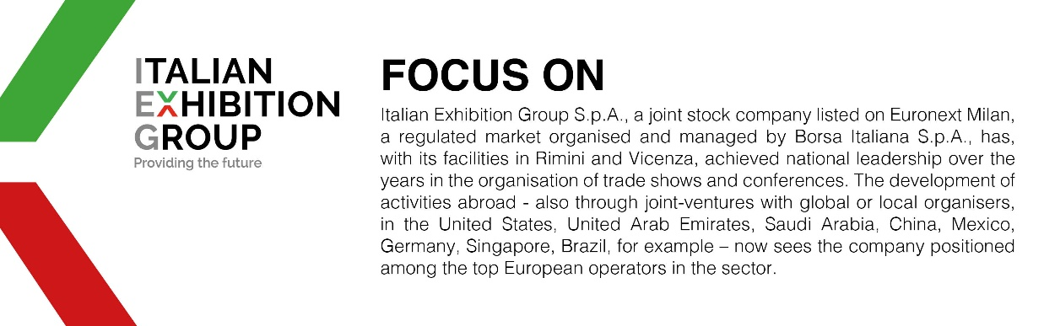

This press release contains forecast elements and estimates that reflect the management´s current opinions (´forward-looking statements´), particularly regarding future management performance, realization of investments, cash flow trends and the evolution of the financial structure. For their very nature, forward-looking statements have a component of risk and uncertainty, as they depend on the occurrence of future events. The effective results may differ (even significantly) from those announced, due to numerous factors, including, only by way of example: food service market and tourist flow trends in Italy, gold and jewellery market trends, green economy market trends; the evolution of raw material prices; general macroeconomic conditions; geopolitical factors and evolutions in the legislative framework. Moreover, the information contained in this release, does not claim to be complete, and has not been verified by independent third parties. Forecasts, estimates and objectives contained herein are based on the information available to the Company as at the date of this release.

