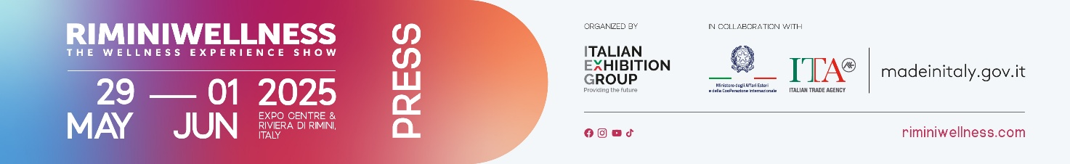

press release
(English translation)

RIMINIWELLNESS 2025 KICKS OFF:
AT THE EXPO AND ALONG THE RIVIERA UNTIL SUNDAY
- Alessandra Locatelli, Minister for Disabilities, delivers a greeting at the opening ceremony
- Four days of physical activity and innovation take centre stage at the major event curated by IEG, dedicated to fitness, wellness, sports, and healthy eating.
- Over 350 brands present and more than 2,000 hours of training
Rimini (Italy), 29 May 2025 – Today marks the opening of the 19th edition of RiminiWellness, an international event dedicated to fitness, wellness, sports, and healthy eating, brought to you by Italian Exhibition Group (IEG). The event was opened with greetings from IEG President Maurizio Ermeti, Rimini Mayor Jamil Sadegholvaad, Assosport Confindustria General Manager Manuela Viel, ICE Consumer Goods Office Director Matteo Masini, Emilia-Romagna Regional President Michele de Pascale, and Paralympic athlete Rigivan Ganeshamoorthy.
The event, which will transform Rimini Expo Centre and the Riviera (Italy) into a global stage for promoting healthy lifestyles until Sunday, June 1, has begun to welcome the energy of the public, including enthusiasts, athletes, and industry professionals, for four days dedicated to innovation in wellness on the move.
In his opening remarks, Maurizio Ermeti recalled that "RiminiWellness is an event that continues to stand out for its ability not only to keep up with the times but to stay ahead of them. This year, the event is even more mature from a professional perspective, featuring high-level content for the entire industry and the presence of major international brands. Ample space is dedicated to innovation, thanks to the participation of young companies and research projects. With the slogan "Face Your Shades," we aim to send out a clear message: embracing your vulnerabilities is the first step to overcoming them and living a life of well-being that is authentic and free from stereotypes.
Jamil Sadegholvaad added: "RiminiWellness is not only one of the top events in the national exhibition calendar, it also marks the launch of a programme that aligns with Rimini's identity as a city of wellness and healthy lifestyles. The event extends beyond the exhibition halls with over 200 RiminiWellness OFF events involving the entire city, from Parco del Mare to the new promenade and Piazza sull'Acqua. This is a structural reflection of how the city has become a reference point for those seeking health, movement, and quality of life”.
Manuela Viel recalled: "We have always believed in this fair and are honoured to be a partner of RiminiWellness, an event that has skilfully managed two essential aspects: an increasingly international B2B platform and a wonderful B2C experience where companies can analyse consumers, engage them, and convey messages." There are numerous challenges in the business world: we are beginning to focus on sustainability, issue of internationalization is being addressed, and we are promoting the growth of sports participation, showing that we want to be an active, sport-conscious population”.
Matteo Masini emphasised: "The global dimension of RiminiWellness is supported by efforts to promote the arrival of foreign delegations." Our presence is strengthened through the organisation of a major international mission, where we will welcome delegates from Europe, Asia, the Middle East, and the United States. These delegates, selected with the support of the ICE network worldwide, will attend an event that highlights Italian excellence and reinforces the presence of Made in Italy in the international wellness landscape.
Michele de Pascale explained that RiminiWellness is "the concrete expression of the regional vision for well-being, development, and social cohesion." Our Sport Valley is a recognised model where sport is an integral part of the regional culture and identity, serving as a true instrument for growth, inclusion, and prevention. We believe that promoting healthy lifestyles not only improves individual health but also strengthens the entire community. This is why promoting movement, well-being, and social interaction is a key driver of our health and social policies, as health is, first and foremost, about prevention”.
Alessandra Locatelli, Minister for Disabilities, also joined the event via video link, stating: "I am pleased to offer my best wishes to this event, as it is crucial for individuals with disabilities or rare degenerative conditions to be able to pursue their well-being through activities and tools dedicated to wellness, including sports and physical activity, with tailored advice and programmes."
Rigivan Ganeshamoorthy, a Paralympian who won Italy's first gold medal at the Paris 2024 Paralympics, is living proof of this: "A medal doesn’t make sport inclusive; inclusivity is the true value of sport." Behind this award lies my past, the hardships and suffering I've endured. It's a gold medal, but the most precious gold is the people who have been close to me, those who have made me so strong in a society that demands strength”.
RIMINIWELLNESS 2025 LIGHTS UP THE EXPO CENTRE AND THE ENTIRE RIVIERA
RiminiWellness 2025 – featuring six large thematic areas spread across 30 halls, with over 350 brands exhibiting and more than 2,000 hours of physical activity – offers a broad and diverse programme. And with RiminiWellness OFF, it extends beyond the expo centre, engaging the entire Riviera and the urban fabric in a full and varied schedule of events that brings wellness and movement to the heart of the city. In the afternoon, the first Sport and Sustainability Forum kicks off, preceded by the usual session on the General States of Fitness and Wellness. Mid-afternoon the results will be announced of the survey conducted by Sole 24 Ore in collaboration with RiminiWellness on "Wellness, the ranking of Italian provinces".
ABOUT RIMINIWELLNESS 2025
Date: 29 May – 1 June 2025; event type: international expo; organiser: Italian Exhibition Group S.p.A.; recurrence: annual; edition: 19th; open to: general public and operators; info: www.riminiwellness.com

PRESS CONTACT ITALIAN EXHIBITION GROUP
head of corporate communication & media relation: Elisabetta Vitali
press office manager: Marco Forcellini, Pier Francesco Bellini | press office coordinator: Luca Paganin | international press office coordinator: Silvia Giorgi | press office specialist: Mirko Malgieri; Nicoletta Evangelisti | media@iegexpo.it

MEDIA AGENCY RIMINIWELLNESS
Naper Multimedia| Zoe Perna | T. +39 02 97699600 | zoe.perna@napermultimedia.it | staff@napermultimedia.it

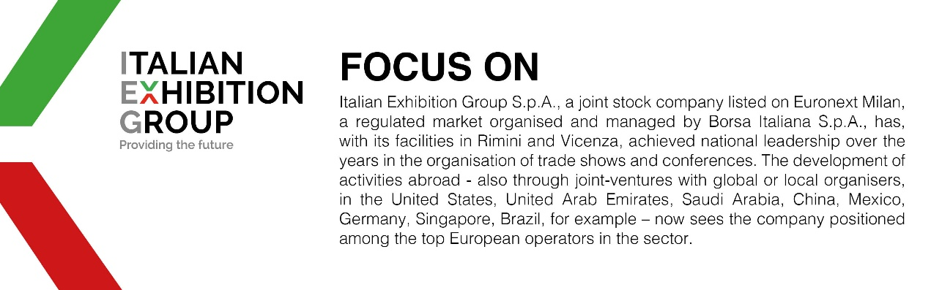

This press release contains forecast elements and estimates that reflect the management’s current opinions (“forward-looking statements”), particularly regarding future management performance, realization of investments, cash flow trends and the evolution of the financial structure. For their very nature, forward-looking statements have a component of risk and uncertainty, as they depend on the occurrence of future events. The effective results may differ (even significantly) from those announced, due to numerous factors, including, only by way of example: food service market and tourist flow trends in Italy, gold and jewellery market trends, green economy market trends; the evolution of raw material prices; general macroeconomic conditions; geopolitical factors and evolutions in the legislative framework. Moreover, the information contained in this release does not claim to be complete, and has not been verified by independent third parties. Forecasts, estimates and objectives contained herein are based on the information available to the Company as at the date of this release.

