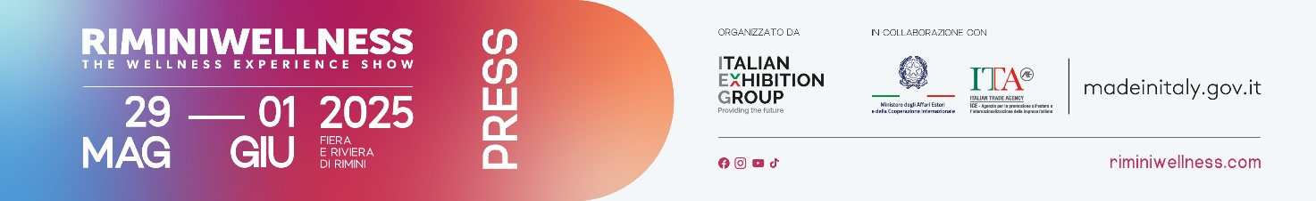

press release no.1

**IEG: RIMINIWELLNESS 2025, THE GLOBAL MANIFESTO FOR HEALTHY LIFESTYLES RIMINI EXPO CENTRE AND ALONG THE RIVIERA FROM MAY 29 TO JUNE 1**

* **The 19th edition of the Italian Exhibition Group event, dedicated to fitness, sports, wellness, and healthy eating, will once again serve as an international showcase for the wellness of the future**
* **Thirty halls and six themed areas dedicated to wellness, spanning over 190,000m2 of indoor and outdoor spaces packed with engaging experiences.**
* **Over 2,000 hours of training and dozens of conferences and professional development sessions**
* **Transforming the local area into the world's largest open-air gym with RiminiWellness OFF**

*Rimini, 29 May – 1 June 2025* – From **May 29 to June 1,** Rimini Expo Centre and the Riviera will once again become the world’s largest gym with the 19th edition of **RiminiWellness**. This international event curated by **Italian Exhibition Group** is dedicated to fitness, sports, wellness, and healthy eating, serving as a true global **manifesto for living a healthy lifestyle**. With "Face your shades" as the slogan for the 2025 edition, the event invites people from all corners of the world to turn their weaknesses into strengths, increasingly focusing on enhancing individual well-being and unique qualities in a journey of personal growth.

**A UNIQUE SPACE FOR FITNESS AND WELLNESS, COMBINING FUN AND BUSINESS**

With **190,000m2 of exhibit space**, **30 halls**, and **6 themed areas**, **RiminiWellness** is much more than just a show: it is the vibrant heart of wellness and fitness on an international scale. The soul of the event is the **ACTIVE area**, a hub of energy and innovation where the latest fitness trends come to life. Participants can experience these trends firsthand through practical, dynamic, and engaging activities. Great anticipation all round for the return of the **Italian Showdown**, an unmissable event for CrossFit® enthusiasts, celebrating its tenth year with competitions open to all skill levels. The programme is made even more intense by the **third Italian edition of HYROX**, a global challenge that will test participants over three days with an explosive mix of running, functional exercises, and strength tests. The **FITNESS area** serves as the stage for the industry’s leading companies, ready to showcase their top equipment, technical clothing, and the most advanced digital technologies. The expanded and elevated **HEALTH area** highlights sports medicine, rehabilitation technologies, nutraceuticals, and a rich educational programme, all thanks to the collaboration with prestigious Italian universities. In the **WELLNESS area**, you can embark on a true experiential journey through holistic disciplines, meditative practices, and services designed for personal well-being. The **FOODWELL area** is a must-see this year, showcasing excellence in functional nutrition with a focus on innovative products and educational opportunities alongside prominent Italian and international brands. Last but not least, over 13,000m2 will be dedicated to the **STEEL** universe, a space for strength disciplines, featuring spectacular events with the participation of world-renowned athletes.

**BUSINESS AND INNOVATION MEET THE WORLD OF WELLNESS**

This edition marks the launch of the first **Forum on Sport and Sustainability**, sponsored by Ecopneus with the support of Ecomondo and institutions like the Milano Cortina 2026 Foundation, MAECI, and UEFA. The training programme will also involve trainers, instructors, and sports managers, with sessions led by industry experts. Key moments include the **Sports Value Observatory of The European House – Ambrosetti,** the **FIPE Conference** with new data on sports training, and the **General States of Fitness and Wellness**, featuring the participation of Italian and international investors. Fitness Franchising Day makes its debut, an exclusive event for entrepreneurs combining training and networking. Promoted by technical partners such as Clust-ER Health, Clust-ER Turismo, UniRimini, Tecnopolo di Rimini, Invitalia, and ANGI (National Association of Young Innovators), the **Innovation Area** will feature 20 selected startups focused on accessibility, sustainability, and mental health, along with an extensive programme of workshops and seminars on innovation.

**RIMINIWELLNESS OFF IS BACK: OUTDOOR ENERGY AND MOTION**

Alongside the hive of activities going on in the Expo Centre, the third edition of RiminiWellness OFF is taking place - an off-site event organised in collaboration with the Municipality of Rimini. An event that expands the boundaries of the venue, extending from the expo centre to the entire city. The 2025 edition features a programme of over 200 events taking place from dawn to dusk in some of the area's most iconic locations, from beaches to city parks. This diverse and accessible offering further solidifies Rimini's role as an international wellness hub, recognised both nationally and globally.

**ABOUT RIMINIWELLNESS 2025**

**Date**: 29 May – 1 June 2025; **event type**: international expo; **organiser**: Italian Exhibition Group S.p.A.; **recurrence**: annual; **edition**: 19th; **open to:** general public and operators; **info**: [www.riminiwellness.com](http://www.riminiwellness.com)

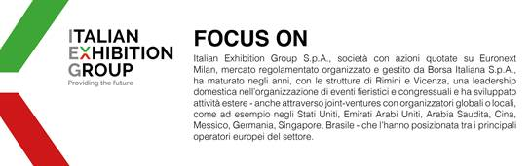

**PRESS CONTACT ITALIAN EXHIBITION GROUP  
head of corporate communication & media relation:** Elisabetta Vitali  
**press office manager**: Marco Forcellini, Pier Francesco Bellini | **press office coordinator**: Luca Paganin | **international press office coordinator:** Silvia Giorgi | **press office specialist:** Mirko Malgieri; Nicoletta Evangelisti | [media@iegexpo.it](http://srvcww.dominio-fiera.local/gestionecww/template/%C2%B4mailto:media@iegexpo.it)

**MEDIA AGENCY RIMINIWELLNESS**

**Naper Multimedia**| Zoe Perna | T. +39 02 97699600 | [zoe.perna@napermultimedia.it](mailto:zoe.perna@napermultimedia.it) | [staff@napermultimedia.it](mailto:staff@napermultimedia.it)

Il presente comunicato stampa contiene elementi previsionali e stime che riflettono le attuali opinioni del management (“forward- looking statements”) specie per quanto riguarda performance gestionali future, realizzazione di investimenti, andamento dei flussi di cassa ed evoluzione della struttura finanziaria. I forward-looking statements hanno per loro natura una componente di rischio ed incertezza perché dipendono dal verificarsi di eventi futuri. I risultati effettivi potranno differire anche in misura significativa rispetto a quelli annunciati, in relazione a una pluralità di fattori tra cui, a solo titolo esemplificativo: andamento del mercato della ristorazione fuori casa e dei flussi turistici in Italia, andamento del mercato orafo - gioielliero, andamento del mercato della green economy; evoluzione del prezzo delle materie prime; condizioni macroeconomiche generali; fattori geopolitici ed evoluzioni del quadro normativo. Le informazioni contenute nel presente comunicato, inoltre, non pretendono di essere complete, né sono state verificate da terze parti indipendenti. Le proiezioni, le stime e gli obiettivi qui presentati si basano sulle informazioni a disposizione della Società alla data del presente comunicato.