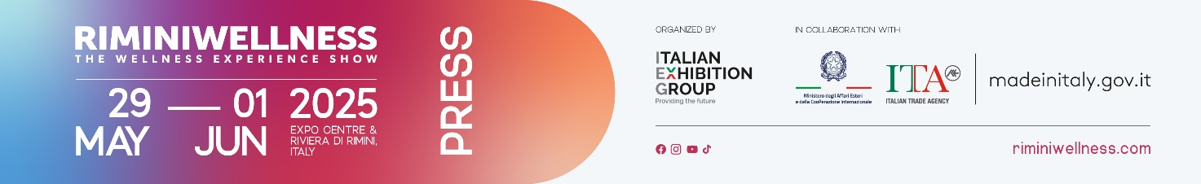
press release no.11

SPORT, TECH AND TRAVEL: MAPPING THE WELLNESS ECONOMY

- 24.7 billion euros: the value of the sports economy in Italy
- 55% of Italians train with the help of technology

Rimini, 29 May – 1 June 2025 – Italy is moving, changing habits, and seeking new ways to thrive. Wellness is no longer just a physical matter: today, it all about active lifestyles, digital awareness, experiential tourism, and innovation. RiminiWellness 2025, the international event curated by Italian Exhibition Group, will be held at Rimini Expo Centre and along the Riviera from May 29 to June 1. The event captures the new face of wellness in Italy and anticipates its future developments.

SPORT IN ITALY: WIDESPREAD POPULARITY AND ECONOMIC IMPACT
According to the 2024 Sports Report, produced by Sport e Salute and the Institute for Sports Credit in collaboration with the Minister for Sport and Youth, the Italian sports industry has solidified its position as a key pillar of the national economy, generating a total value of over 24 billion euros, equivalent to approximately 1.4% of the GDP. Beyond its economic dimension, sport is increasingly recognised as a factor of inclusion, a territorial anchor, and a driver of active participation. Across the entire peninsula, there are over 112,000 Amateur Sports Organisations, with a total of more than 13 million Italian members. Among the most popular non-competitive activities, gymnastics and fitness lead with 15.2%, followed by football at 9.2%, dance at 7.1%, athletics at 4.3%, cycling at 4.2%, volleyball at 3.9%, tennis and padel at 3.5%, weightlifting at 3.5%, and basketball at 2.9%. This confirms a broad and diverse sports landscape. Employment is also showing signs of consolidation: in 2022, the industry registered 412,479 workers, marking a 2.5% increase from 2021, when there were 402,291 employees, confirming an ongoing positive trend.

ITALY BALANCING SEDENTARY LIFESTYLES AND A NEW CULTURE OF WELLNESS
According to the Valore Sport 2025 Observatory, conducted by The European House – Ambrosetti, despite the progress made in recent years, Italy remains one of the most sedentary countries in the OECD area. 80.3% of adults and 91.7% of children do not meet the minimum levels of physical activity recommended by the WHO, placing us in fourth place for physical inactivity after Turkey, Portugal, and Greece. Yet, alongside this critical picture, encouraging signs are emerging. Since 2001, the proportion of the population that is completely inactive has decreased by over 7% while continuous sports practice has increased by over 9%, indicating a greater awareness of the importance of movement. In terms of infrastructure, the country has 76,919 sports facilities, with an average of 131 facilities per 100,000 inhabitants, which is lower than in other European countries. However, the rates of inactivity remain high among over 65s (83.6%), individuals with a low level of education (68.6%), women (68.4%), residents of the South and Islands (72.5%), in small towns (71%), and urban suburbs (64.3%). Italy appears to be torn between a tradition of inactivity and a new drive towards well-being. In this context, RiminiWellness stands out as a key event: it promotes a culture of movement and well-being, engaging diverse regions and audiences, and breaking down cultural and social barriers. It's not just a show, it’s a workshop of experiences that helps make fitness more accessible, inclusive, and motivating.

TECHNOLOGY SUPPORTING NEW TRAINING METHODS IN THE GYM
In the new approach to self-care, technology plays a key role in daily workouts. Even in the gym, technology is increasingly present: apps, devices, and digital platforms help monitor activity, integrating with the work of trainers and personalised programmes. Tools such as pedometers, heart rate monitors, and calorie tracking systems are regularly used, reflecting a more conscious and tailored approach. The support of a personal trainer, chosen by one in three Italians, remains central. Frequency is high: nearly one in two people train at least three times a week, and one in seven does five sessions per week. Among the most popular activities are running, yoga, Pilates, gym, soccer, and swimming. Mental well-being is now the primary motivation, followed by health and physical fitness - a sign of an Italy that is increasingly aware and attentive to its own balance.

WELLNESS IS ALSO DRIVING TOURISM
The growth of wellness is also spreading to tourism, where it is emerging as one of the most significant trends in Italy. According to the latest Global Wellness Economy Monitor 2024, conducted by the Global Wellness Institute, our country recorded 13 million wellness-related trips, with a total expenditure of 19.2 billion dollars. These numbers position Italy among the world's most sought-after destinations for those seeking experiences focused on psycho-physical balance. Wellness tourism is divided into two main categories: primary trips, where the main motivation is wellness, and secondary trips, which integrate healthy activities into stays with other purposes. The latter account for 88% of trips and 85% of spending in the industry, confirming a growing trend: the desire for wellness is also making its way into more traditional business or leisure trips. Italian accommodation facilities are responding to this demand with increasingly targeted services: spas, healthy eating, physical activities, meditation, and tailored treatments.

Sources: Unisalute Health Observatory – Eumetra | Sports Value Observatory 2025 – Studio Ambrosetti | Sports Report 2024 – Sports and Health Studies Centre | Global Wellness Institute (GWI)

ABOUT RIMINIWELLNESS 2025
Date: 29 May – 1 June 2025; event type: international expo; organiser: Italian Exhibition Group S.p.A.; recurrence: annual; edition: 19th; open to: general public and operators; info: www.riminiwellness.com

PRESS CONTACT ITALIAN EXHIBITION GROUP
head of corporate communication & media relation: Elisabetta Vitali
press office manager: Marco Forcellini, Pier Francesco Bellini | press office coordinator: Luca Paganin | international press office coordinator: Silvia Giorgi | press office specialist: Mirko Malgieri; Nicoletta Evangelisti | media@iegexpo.it

MEDIA AGENCY RIMINIWELLNESS
Naper Multimedia| Zoe Perna | T. +39 02 97699600 | zoe.perna@napermultimedia.it | staff@napermultimedia.it

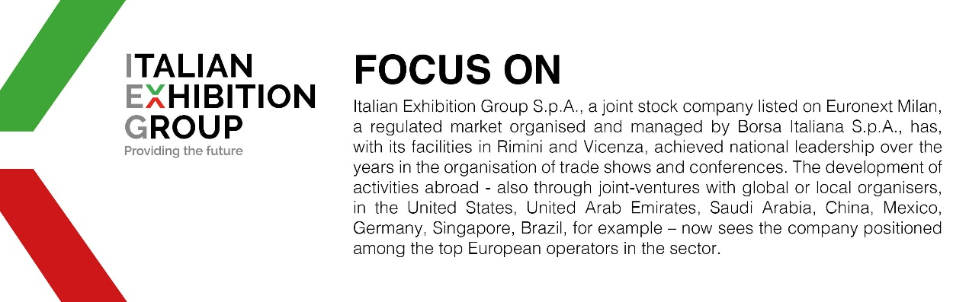

This press release contains forecast elements and estimates that reflect the management’s current opinions (“forward-looking statements”), particularly regarding future management performance, realization of investments, cash flow trends and the evolution of the financial structure. For their very nature, forward-looking statements have a component of risk and uncertainty, as they depend on the occurrence of future events. The effective results may differ (even significantly) from those announced, due to numerous factors, including, only by way of example: food service market and tourist flow trends in Italy, gold and jewellery market trends, green economy market trends; the evolution of raw material prices; general macroeconomic conditions; geopolitical factors and evolutions in the legislative framework. Moreover, the information contained in this release does not claim to be complete, and has not been verified by independent third parties. Forecasts, estimates and objectives contained herein are based on the information available to the Company as at the date of this release.

