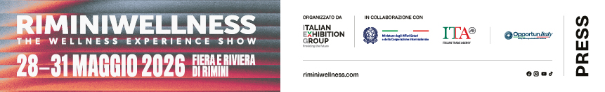

press release 8

WELLNESS DRIVES NEW CONSUMPTION
BETWEEN FITNESS, TECHNOLOGY AND THE WELLNESS ECONOMY

- The global wellness economy amounts to 6.8 trillion dollars and aims to reach 9.8 trillion by 2029
- Italy is among the world's top 10 wellness economies with a market worth 140.6 billion dollars
- Physical inactivity is decreasing in Italy, going from 40% to 33% in 10 years

Rimini, 28-31 May 2026 – The wellness world is one of the main drivers of new consumption and lifestyle. An evolution that involves physical activity, prevention, health, tourism and technological innovation, contributing to the growth of an increasingly strategic sector, also from an economic and social point of view. In this context, RiminiWellness 2026, Italian Exhibition Group’s fitness, sport and wellness event, back for its twentieth edition from 28th to 31st May at Rimini Expo Centre and on the Riviera, confirms its status as a privileged observatory on the trends that are redefining the market and the development prospects of the entire supply chain.

ITALY AMONG THE WORLD’S TOP 10 WELLNESS ECONOMIES
Wellness is increasing its weight on a global economic level, confirming the sector’s importance in contemporary consumption evolution. According to the Global Wellness Institute, the global wellness economy has now exceeded 6.8 trillion dollars and could reach 9.8 trillion by 2029, growing at a faster rate than the global economy. Transversal sectors, from physical activity to nutrition, prevention, mental health, wellness tourism, preventive medicine and technologies applied to wellness, all contribute to this expansion. In this context, Italy is among the top ten wellness economies, ranking 10th globally and 4th in Europe with a market that has reached a value of 140.6 billion dollars. A result supported by the strength of supply chains historically linked to the Italian lifestyle, such as wellness tourism, spas, healthy eating, sport and hospitality, which contribute to boosting the country's positioning among the main international wellness destinations. In Italy, this evolution is also reflected in the growing popularity of sport practices and wellness activities. The Italian Fitness Federation declares that in 2025, the Italian fitness market had an estimated value of 3.1 billion euros, confirming the growing diffusion of physical activity and wellness services. Over 7,500 gyms and fitness centres operated throughout the country with more than 5 million members, while almost 18 million Italians used services related to fitness and wellness, even occasionally. A scenario that confirms how wellness is no longer just a consumption trend, but a strategic lever for economic development, innovation, territorial appeal and quality of life, encouraging the creation of increasingly integrated sport, wellness, tourism and sociality experiences.

IN ITALY, MORE SPORT AND LESS PHYSICAL INACTIVITY
The growing attention to health and quality of life can be seen in the diffusion of sports and physical activity within the country. The Ministry for Sport and Youth’s Sport 2025 Report highlights that two out of three Italians now practice sport or physical activity and 38 million Italians are involved in physical and sporting activities, confirming sport’s increasingly central role in contemporary lifestyles.
According to data from The European House – Ambrosetti’s Sport Value Observatory, the share of the population that is completely sedentary fell from 40% in 2015 to 33% in 2024 with around 4.7 million fewer inactive people in less than ten years. However, strong territorial and sociodemographic differences still persisted with higher levels of inactivity among women, the over 65s, residents in the South and people with a low level of education.
In an international comparison, according to the most recent OECD and WHO findings contained in Health at a Glance 2023, Italy ranked as the fourth most sedentary OECD country with 80.3% of the population not achieving the recommended levels of at least 150 minutes of physical activity per week, compared to an OECD average of 59.6%. The data were subject to a more restrictive definition of sedentary lifestyle, which considers the overall level of physical activity carried out not only during free time, but also at home and at work, according to WHO guidelines.
Sedentary lifestyle also has a significant impact on the national economic and healthcare system, generating costs estimated at around 6.7 billion euros per year between healthcare spending and loss of productivity. A framework that shows how promoting physical activity is not only a public health priority these days, but also a strategic lever for the social and economic sustainability of the country

FITNESS, TECHNOLOGY AND AI: HOW THE SPORT EXPERIENCE IS CHANGING
The fitness sector is undergoing a profound technological transformation that is redefining training methods and monitoring health and performance. Online platforms, wearable devices, on-demand training and connected equipment are accelerating the sector’s digitalisation. According to IMARC Group, connected gyms integrated with intelligent systems, digital services and personalised training are on the increase. The global connected fitness equipment market could reach $10.3 billion by 2033 with average annual growth exceeding 20%. According to Mordor Intelligence, wearables, AI coaching and hybrid training are transforming fitness centres into increasingly personalised and data-driven environments. The Italian market for wellness devices is also growing, driven by the popularity of tools for health monitoring, prevention and psychophysical well-being. A transformation that confirms an increasingly integrated fitness evolution, oriented not only towards performance but also towards preventive health and corporate wellness.

WELLNESS TOURISM IS RUNNING FASTER THAN TRADITIONAL TOURISM
Wellness evolution also involves tourism driven by the demand for experiences oriented towards wellness and personal care. According to Global Market Insights, the global wellness tourism market reached a value of 975 billion dollars in 2025 and, based on current projections, will exceed 2.1 trillion dollars by 2035, with an average annual growth of 8.2%.
Globally, the sector is driven by experiences related to health, regeneration and outdoor activities. Wellness resorts, retreats, spas and sports tourism are redefining the international tourist offer, creating new opportunities for territories and sector operators.
In this scenario, Italy is one of the most important markets in the tourist wellness economy. The sector directly linked to wellness tourism, spas and hot springs was worth almost 27 billion dollars in 2024, while the wellness tourism segment alone stood at 19.99 billion dollars, positioning itself among the national wellness economy’s five main sectors. Furthermore, as reported by the TEHA Group’s Sport Value 2025 Observatory (The European House - Ambrosetti), Eurostat data highlight how sports and outdoor tourism were responsible for 8% of tourist arrivals in Italy and was the fourth reason for visits. Attendance linked to sport accounted for 14% of the total. The phenomenon was more concentrated in the North (21.6% of arrivals) compared to the Centre (13.8%) and the South (6.7%).

Sources: Global Wellness Institute and Insights | Italian Fitness Federation | 2025 Sport Report | Sport Value Observatory of The European House – Ambrosetti | Connected Gym Equipment Market | Mordor Intelligence

ABOUT RIMINIWELLNESS 2026
Dates: 28/31 May 2026; event: international trade show; organisation: Italian Exhibition Group S.p.A.; frequency: annual; edition: 20th; entry: public and trade; info: www.riminiwellness.com

PRESS CONTACT ITALIAN EXHIBITION GROUP
head of corporate communication & media relation: Elisabetta Vitali
press office manager: Marco Forcellini, Pier Francesco Bellini | press office coordinator: Luca Paganin | press office specialist: Mirko Malgieri; Nicoletta Evangelisti | press office assistant: Julia Andreatta media@iegexpo.it

MEDIA AGENCY RIMINIWELLNESS 2026
Naper Multimedia| Zoe Perna | T. +39 02 97699600 | zoe.perna@napermultimedia.it | staff@napermultimedia.it

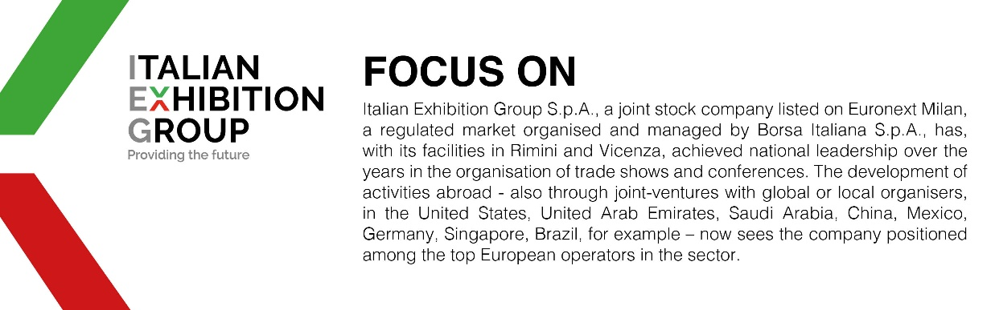

This press release contains forecast elements and estimates that reflect the management´s current opinions (´forward-looking statements´), particularly regarding future management performance, realization of investments, cash flow trends and the evolution of the financial structure. For their very nature, forward-looking statements have a component of risk and uncertainty, as they depend on the occurrence of future events. The effective results may differ (even significantly) from those announced, due to numerous factors, including, only by way of example: food service market and tourist flow trends in Italy, gold and jewellery market trends, green economy market trends; the evolution of raw material prices; general macroeconomic conditions; geopolitical factors and evolutions in the legislative framework. Moreover, the information contained in this release, does not claim to be complete, and has not been verified by independent third parties. Forecasts, estimates and objectives contained herein are based on the information available to the Company as at the date of this release.

