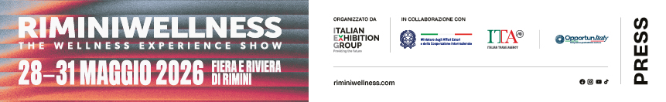

press release 10

RIMINIWELLNESS 2026: WELLNESS TOURISM IS DRIVING
THE NEW WELLNESS ECONOMY

- Italy among the world’s top 10 wellness economies with a market worth 140.6 billion dollars
- At this edition, focus on tourism as it evolves from an escape experience to a tool for active regeneration
- Wellness tourism, sport tourism, slow tourism and bleisure formulas are becoming new models of Italian hospitality

Rimini, 28-31 May 2026 - Italy is now among the world’s top ten wellness economies ranking 10th globally and 4th in Europe. A market, according to the Global Wellness Institute, worth 140.6 billion dollars that highlights the strength of the country’s wellness, spa, sports and hospitality tourism supply chains. In this context, RiminiWellness 2026, Italian Exhibition Group’s event, back for its twentieth edition from 28th to 31st May at Rimini Expo Centre and on the Riviera, confirms its status as a privileged observatory on the transformations that are redefining contemporary tourism as it increasingly looks to health, longevity, outdoor experiences and quality of life.

WELLNESS TOURISM ECONOMY: FROM TRAVEL TO REGENERATIVE EXPERIENCE
At RiminiWellness, wellness tourism is increasingly portrayed as an integrated ecosystem that combines health, territory, longevity and quality of life. Travel is becoming a tool for physical and mental regeneration, oriented towards healthspan, prevention and psychophysical rebalancing. According to Grand View Research, the global wellness tourism market will exceed 2.1 trillion dollars by 2035 with an average annual growth of 8.2%, and Italy is one of the most important markets. According to the “Global Wellness Economy: Italy” report, published by the Global Wellness Institute in 2026, the wellness tourism, spa and hot spring sector was worth around 27 billion dollars in 2024, while the wellness tourism segment alone stood at 19.99 billion dollars. Furthermore, as reported by the TEHA Group’s Sport Value 2025 Observatory (The European House - Ambrosetti), Eurostat data highlight how sports and outdoor tourism were responsible for 8% of tourist arrivals in Italy and was the fourth reason for visits. Attendance linked to sport accounted for 14% of the total. The phenomenon was more concentrated in the North (21.6% of arrivals) compared to the Centre (13.8%) and the South (6.7%).

SLOW TOURISM, CYCLE TOURISM AND NEW TERRITORIAL MODELS
The data and analyses presented at the show by CNA Emilia-Romagna will regard this scenario, highlighting how Slow Tourism, cycle tourism and territorial experiences contribute to establishing new local economic models. Speakers will include Roberta Frisoni, regional councillor for Tourism, Laura Sillato, president of CNA Tourism and Trade Emilia-Romagna, Nicola Cesari, mayor of Sorbolo Mezzani, Susanna Maggioni, vice president of FIAB Italy, and Christian Bertoni, vice president of APS Senio and Gesso. The debate will focus on experiences such as the Food Valley Bike and daily hospitality models that combine gentle mobility, local culture, wellness and sustainability. New forms of slow and outdoor tourism that enhance the landscape and the quality of the experience, thus contributing to the growth of local economies and secondary destinations, will also be discussed. The programme, organised by Paola Rizzitelli, expert in systemic well-being, will open with the talk “Living in health is brilliant!” and will continue with the panel discussion entitled “The future scenarios of Wellness Tourism”. Participating in the debate will be: Annalisa Giannini from IEG, Raffaella Disipio from Italcares Confindustria Federterme, longevity medicine doctor Vincenzo Primitivo, Simona Tedesco from DOVE, Elena Andreolli from Terme di Comano, Giacomo Bullo rom ALMA and Carlo Goretti from Acqua e Terme di Fiuggi. A discussion on wellness hospitality’s new perspectives between health, longevity, spas and experiential tourism.

BLEISURE, FOREST BATHING AND NEW EXPERIENTIAL TOURISM FORMATS
Wellness tourism transformation also involves the MICE (Meetings, Incentives, Conferences, Events) sector, which is increasingly oriented towards bleisure (business & leisure) formulas that transform conferences and professional events into opportunities for wellness, networking and local discovery. Besides business travel, new models of regenerative tourism are also growing, based on immersive health, sport, outdoors and quality of life experiences. Emerging trends such as forest bathing and integrated sports resorts that combine performance, relaxation and wellbeing, are part of this scenario. A further focus will be on the international experience of Playitas Resort in Fuerteventura, an active wellness tourism model that integrates Hyrox and Triathlon, an Olympic swimming pool, outdoor programmes and activities for families and athletes in an ecosystem that aims at physical and mental regeneration.

ABOUT RIMINIWELLNESS 2026
Dates: 28/31 May 2026; event: international trade show; organisation: Italian Exhibition Group S.p.A.; frequency: annual; edition: 20th; entry: public and trade; info: www.riminiwellness.com

PRESS CONTACT ITALIAN EXHIBITION GROUP
head of corporate communication & media relation: Elisabetta Vitali
press office manager: Marco Forcellini, Pier Francesco Bellini | press office coordinator: Luca Paganin | press office specialist: Mirko Malgieri; Nicoletta Evangelisti | press office assistant: Julia Andreatta media@iegexpo.it

MEDIA AGENCY RIMINIWELLNESS 2026
Naper Multimedia| Zoe Perna | T. +39 02 97699600 | zoe.perna@napermultimedia.it | staff@napermultimedia.it

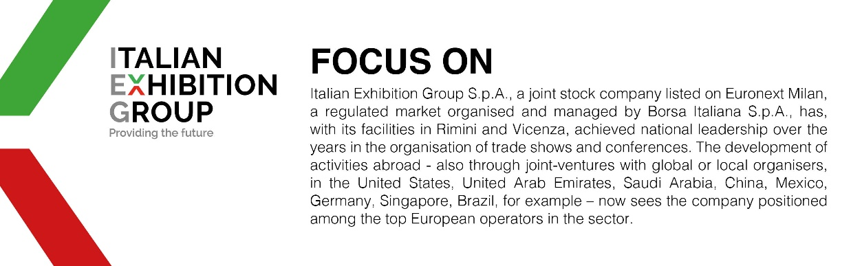

This press release contains forecast elements and estimates that reflect the management´s current opinions (´forward-looking statements´), particularly regarding future management performance, realization of investments, cash flow trends and the evolution of the financial structure. For their very nature, forward-looking statements have a component of risk and uncertainty, as they depend on the occurrence of future events. The effective results may differ (even significantly) from those announced, due to numerous factors, including, only by way of example: food service market and tourist flow trends in Italy, gold and jewellery market trends, green economy market trends; the evolution of raw material prices; general macroeconomic conditions; geopolitical factors and evolutions in the legislative framework. Moreover, the information contained in this release, does not claim to be complete, and has not been verified by independent third parties. Forecasts, estimates and objectives contained herein are based on the information available to the Company as at the date of this release.

