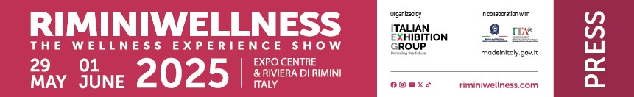

press release
(English press release)

WELLNESS IN ALL ITS SHADES, ONLY
At RIMINIWELLNESS 2025

- An immersive experience blending sports, innovation, and the latest trends
- "Face Your Shades": Unlock your full potential and discover all-round wellness
- Italian Showdown and HYROX: the unmissable competitions are back at RiminiWellness

Rimini (Italy), 5 February 2025 – RiminiWellness is ready to make a comeback! The 19th edition of Italy's largest event dedicated to fitness, sports, and wellness will take place from May 29 to June 1, 2025, at Rimini Expo Centre and along the Riviera, once again transforming the city into the capital of wellness. Curated by Italian Exhibition Group (IEG), this event is not just a show, it’s an authentic catalyst for experiences, innovation, and business for professionals, enthusiasts, and companies. A unique opportunity to experience wellness as a path to personal and professional growth.

All the shades of wellness
This year, RiminiWellness is introducing the "Face Your Shades" initiative, which is much more than just a slogan. It's an invitation to look within, recognise our fears, and transform them into strength. How often have insecurities held us back from reaching our full potential? The Wellness Experience Show is bursting with new shades, providing a free and inclusive environment where everyone can unleash their passions and shine. This is the perfect opportunity to challenge yourself, break through mental and physical barriers, and uncover unexpected inner resources. RiminiWellness is not just for those seeking the perfect physique, but for anyone seeking balance between body and mind, with comprehensive wellness programmes. The industry's top experts will be on hand to provide personalised advice, guiding each visitor on their unique path to wellness. RiminiWellness is also a gathering place for those who share a common passion, a chance to share experiences, motivate each other, and find inspiration. "Face Your Shades" is an invitation to turn weaknesses into strengths, as it's in our unique nuances that we truly shine.

Two unmissable events for fitness enthusiasts
The 2025 edition of RiminiWellness will occupy the entire expo area, including the two recently inaugurated halls, and will host two iconic events: Italian Showdown and HYROX. The first event has reached its tenth anniversary, establishing itself as the undisputed benchmark for the CrossFit® community. A competition open to all, divided into three categories – beginner, intermediate, and advanced – to allow athletes of all levels to test themselves in a competitive and motivating environment. More than just a race, this experience celebrates the passion for fitness and the drive to excel. Additionally, HYROX, now in its third and most spectacular Italian edition, will unfold over three days of pure adrenaline, marking a first for our country. This fitness race, taking the world by storm, combines running, functional training, and strength tests. It offers a unique experience with the Open, Doubles, Pro, and Relay divisions, allowing you to challenge yourself, have fun, and share your passion with a global community.

Rimini: the ultimate Wellness Destination
Rimini, the beating heart of the event, is increasingly recognised as the ultimate Wellness Destination. Here, wellness is a year-round affair, thanks to the perfect blend of sea, sports, nature, and culture. From training courses on the beach, along the entire Parco del Mare, the largest open-air gym in Europe, to outdoor activities in the Romagna hills, to the thermal baths and specialised centres, Rimini is the perfect destination for those seeking a healthy and dynamic lifestyle. RiminiWellness celebrates and strengthens its connection with the region, offering an experience that transcends the boundaries of the fair and embraces the city and its vibrant energy.

ABOUT RIMINIWELLNESS 2025
Date: 29 May – 1 June 2025; type: international show; organiser: Italian Exhibition Group S.p.A.; recurrence: annual; edition: 19th; open to: general public and operators; info: www.riminiwellness.com

PRESS CONTACT ITALIAN EXHIBITION GROUP
head of corporate communication & media relation: Elisabetta Vitali
press office manager: Marco Forcellini, Pier Francesco Bellini | press office coordinator: Luca Paganin | international press office coordinator: Silvia Giorgi | press office specialist: Mirko Malgieri; Nicoletta Evangelisti | media@iegexpo.it

MEDIA AGENCY RIMINIWELLNESS
Naper Multimedia| Zoe Perna | T. +39 02 97699600 | zoe.perna@napermultimedia.it | staff@napermultimedia.it

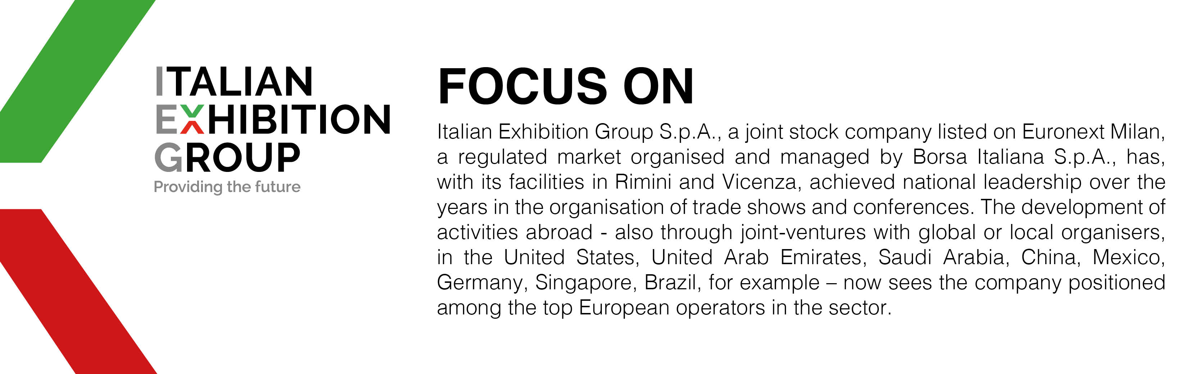

This press release contains forecast elements and estimates that reflect the management’s current opinions (“forward-looking statements”), particularly regarding future management performance, realization of investments, cash flow trends and the evolution of the financial structure. For their very nature, forward-looking statements have a component of risk and uncertainty, as they depend on the occurrence of future events. The effective results may differ (even significantly) from those announced, due to numerous factors, including, only by way of example: food service market and tourist flow trends in Italy, gold and jewellery market trends, green economy market trends; the evolution of raw material prices; general macroeconomic conditions; geopolitical factors and evolutions in the legislative framework. Moreover, the information contained in this release does not claim to be complete, and has not been verified by independent third parties. Forecasts, estimates and objectives contained herein are based on the information available to the Company as at the date of this release.

