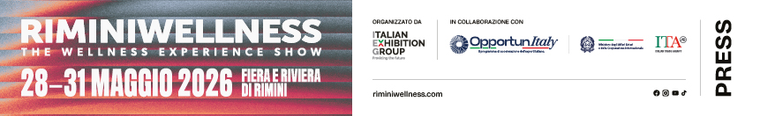

press release 4

RIMINIWELLNESS 2026: TECHNOLOGICAL INNOVATION TRACES
THE NEW BOUNDARIES OF WELLNESS AND PERFORMANCE

- The Innovation Area at Italian Exhibition Group’s event will be extended to host 30 start-ups, affirming its role as a strategic hub for innovation and international technological research
- From Sport & Space Economy to active longevity: from 28-31 May at Rimini Expo Centre, cutting-edge solutions in artificial intelligence, wearables and functional nutrition
- Business strategies and training: from the panel discussion on Longevity to the debut of Reverse Pitching and new projects for schools.

Rimini, 28-31 May 2026 – The consolidation of the Innovation Area at RiminiWellness, the international event of reference for the wellness industry, organised by IEG -Italian Exhibition Group, marks a new milestone in technology and health integration. In 2026, the initiative will be reasserting its role as a prime observatory for identifying the sector’s most advanced trends, from preventive medicine to sports tourism. A dynamic ecosystem where 30 start-ups, scale-ups and university spin-offs will be presenting wearable devices, digital applications and AI services ready to revolutionise the nutrition, fitness and longevity sectors.
ADVANCED SYSTEMS AND BIOTECHNOLOGIES: EVOLUTIONS IN PERFORMANCE AND SAFETY
The Innovation Area will redefine the parameters of wellbeing through solutions that combine automation and bioengineering. Personal hygiene will evolve with Clean OS S.r.l.’s SmartBrush, designed for deep and thorough cleaning in just 30 seconds per arch, whilst the professional fitness sector will embrace the wireless technology of Austrian firm GO PRO ICON EMS GmbH, whose 26-electrode suit ensures full muscle activation in 20-minute sessions. Club optimisation will be achieved through FitButlr™ by GYM3000.com, the intelligent NFC towel that allows managers to monetise services by digitising users’ established habits. On the deep well-being front, Health Spectrum Laboratories will be presenting WAVE, a carbon-fibre chaise longue that uses Harmonic Frequencies to induce relaxation, whilst the semantic artificial intelligence developed by Myndoor s.r.l. monitors early signs of stress. Lastly, athlete safety will entrust in research by O-DAMP, a Bologna University spin-off that integrates non-Newtonian fluids into protective gear that can neutralise rotational accelerations, the main cause of head injuries.

FUNCTIONAL NUTRITION AND NEW DIGITAL MODELS
Nuhpro srl will be demonstrating the evolution of food as medicine with functional nutrition and longevity solutions designed to combat sarcopenia and support women’s health. In physical recovery, PureVital will be introducing the infrared ozone sauna and active oxygen for deep detoxification and energy boost, whilst SportID will digitise the relationship between athletes and facilities through its Digital Sports Identity (IDS), integrating technical and management data. Business model scalability in wellness tourism will be the focus of The Crowd, a crowdfunding and ticketing platform designed to co-design events and retreats by validating market demand in real time.
BUSINESS STRATEGIES AND PROFESSIONAL NETWORKING
The Fitness Innovation Arena will open on Thursday 28th May with an EPSI (European Platform for Sport Innovation) workshop entitled “Active Ecosystems: Aligning Investment and Innovation”, organised and moderated by Alberto Bichi, Executive Director of EPSI, with contributions from Kristina Jokelainen, founder of SmartNorth Ltd and expert in Smart Specialisation, Building Regional Ecosystems, Interregional Collaboration and EU Affairs, and Mike Yang, Founder and CEO of AquaBloom International Sports Technology Group. The technical-scientific programme, coordinated by Tecnopolo in Rimini, Bologna University and Clust-ER Health and Tourism, will include two workshops on Saturday 30th in the Fitness Innovation Arena: “Development Trends for Start-ups: Internationalisation and Funding Sources” with representatives from the Ministry of Foreign Affairs and International Cooperation (MAECI), the Italian Trade Agency (ITA), Venture Capital, Istituto Credito Sportivo e Culturale and Sella Lab; and “The Incubator and Accelerator System: a comparison of models”, attended by various innovation incubators such as Cesena Lab, San Marino Innovation, Wylab, Trentino Sviluppo, Le village and ALMA CUBE. The day will culminate with Reverse Pitching, moderated by Cluster Health: a dynamic session in which investors, advisors and accelerator programmes will take to the stage to explain to start-ups what they are looking for in innovative wellbeing and digital health projects. Therefore, instead of the start-ups making their presentations, key players in the innovation ecosystem will be sharing priorities, evaluation criteria, emerging trends and the areas of greatest market interest. Invitalia, the National Development Agency, will be one of the Innovation area’s technical partners and will also sit on the judging panel to evaluate the selected start-ups’ pitches, awarding a prize in the form of services (guidance, support and matchmaking) to the top three. The Invitalia desk will also be available to provide information on the range of incentives and services the Agency offers to innovative start-ups and also host one-to-one meetings for start-up founders and aspiring entrepreneurs.
LONGEVITY AND RESEARCH: ECONOMIC AND SCIENTIFIC SCENARIOS
With a global value of €500 billion, longevity is emerging as an economic asset and will be the strategic focus of the “Longevity and Lifestyle: Science, Business and Investment” panel discussion. The meeting will address the sector’s evolution in Italy and Europe, combining the bio-scientific expertise of Lucia Magnani, CEO of Lucia Magnani Health Clinic, and Francesco Dalla Villa, Scientific Director at Isokinetic, with market trends analysed by Daniela Bianco, partner at Community Longevity+. Investment trends and M&A activities for wellness centre consolidation will be summarised in presentations by Marco Biffi, CEO of Business Fit Consulting, and Luca Amedeo Masobello, partner at Vam Investments, who will outline the sector’s new paths to profitability. The scientific programme will draw to an end on Sunday 31st May with the academic excellence of the Ilenia Scarantino Award, promoted by Gruppo Sicilia in collaboration with the Universities of Palermo and Catania: Sports Science students from the respective universities will present targeted research on Sicilian phytonutrients and their decisive impact on high-level sporting performance.
EDUCATION, PREVENTION AND MENTAL WELLBEING
The “RiminiWellness for Schools” project will be presented In the Performance Arena on Saturday 30th May. Developed in collaboration with Unigoo, an organisation that specialises in the development of educational experiences and educational trips, the event will feature former swimming champion Massimiliano Rosolino. On the same day, the Wellness Arena will be staging the RiminiWellness premiere of “The Heart Show”, the immersive format by cardiologist and populariser Davide Terranova, supported by FIF, which transforms prevention into an emotional and immersive narrative. On Thursday 28th in the Performance Arena, the focus will be on the use of biofeedback and neurofeedback for stress management in clubs, with Igor Castiglia and his talk “From Fitness to Stress Management”.
ABOUT RIMINIWELLNESS 2026
Dates: 28/31 May 2026; event: international trade show; organisation: Italian Exhibition Group S.p.A.; frequency: annual; edition: 20th; entry: public and trade; info: www.riminiwellness.com

PRESS CONTACT ITALIAN EXHIBITION GROUP
head of corporate communication & media relation: Elisabetta Vitali
press office manager: Marco Forcellini, Pier Francesco Bellini | press office coordinator: Luca Paganin | press office specialist: Mirko Malgieri; Nicoletta Evangelisti | press office assistant: Julia Andreatta media@iegexpo.it

MEDIA AGENCY RIMINIWELLNESS 2026
Naper Multimedia| Zoe Perna | T. +39 02 97699600 | zoe.perna@napermultimedia.it | staff@napermultimedia.it

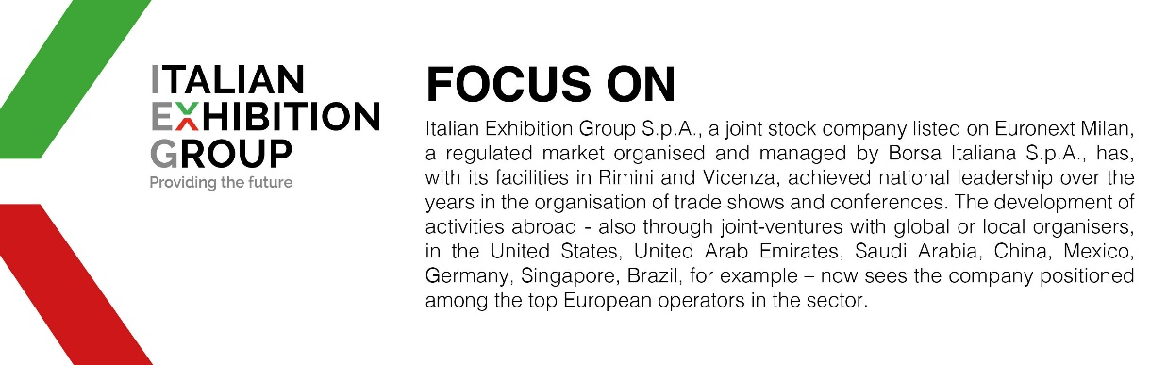

This press release contains forecast elements and estimates that reflect the management´s current opinions (´forward-looking statements´), particularly regarding future management performance, realization of investments, cash flow trends and the evolution of the financial structure. For their very nature, forward-looking statements have a component of risk and uncertainty, as they depend on the occurrence of future events. The effective results may differ (even significantly) from those announced, due to numerous factors, including, only by way of example: food service market and tourist flow trends in Italy, gold and jewellery market trends, green economy market trends; the evolution of raw material prices; general macroeconomic conditions; geopolitical factors and evolutions in the legislative framework. Moreover, the information contained in this release, does not claim to be complete, and has not been verified by independent third parties. Forecasts, estimates and objectives contained herein are based on the information available to the Company as at the date of this release.

